Planes Outline

Strategy Plane
User Needs  - High variety in demographics  - ~ 45K students total  - ~18-70-year-old  - ~150 countries worldwide  - Mother tongue: 48.5% English; 20.1% French; 31.4% other  - 79% undergrad; 21% grad  - ~50% male; 50% female  - 71% QC students; 8.2% Other provinces; 20.6% international  - International: 50% engineering; 21% arts & science  - International: 22.1% Indian; 17.4% Chinese; 11.4% Iran  - Overall: 40.4% arts & science; 22.4% engineering; 20.7 business; 8.3% fine art, 6% independent  - Top 4 undergrad programs: arts & science; engineering; fine arts; business  - Top 4 grad programs: engineering; arts & science; fine arts; business  - Undergrad: 51.9% female; 48.1% male  - Grad: 42.8% female; 57.2% male  - Grad: 76% masters; 14% diploma; 8% PhD  - See Personas  Demographic Information taken from: Concordia University (n.d.). Fast Facts: Concordia in Numbers. Retrieved February 5, 2020 from https://www.concordia.ca/about/fast-facts.html | Product Objectives  - Define artificial intelligence  - Recognize artificial intelligence as a spectrum  - Reflect on the importance of monitoring your health  - Recognize how they can use artificial intelligence to monitor their health  Business Objectives (incl brand identity and success metrics)  - Success metrics  - How many people view the course  - How people perform on the quizzes  - Brand identity  - Concordia  - Business Objective  - Provide students with information and tools about how AI can help them improve/monitor their health
Scope Plane
Functional Specifications  - Desktop usability  - Captivate  - Didacte | Content Requirements  - What is AI video  - ~3-4 minutes  - AI spectrum image - ~300x300 pixels  - AI and your health video  - ~1-3 minutes  - Knowledge check  - After what is AI  - After AI and your health  - AI as your health Ally  - Overall health  - Human body icon - ~400x150 pixels  - Brain health  - Brain icon - ~ 40x40 pixels  - Stomach health  - Stomach icon - ~ 40x40 pixels  - Heart health  - Heart icon - ~ 40x40 pixels  - Genitals health  - Male genitals icon - ~ 20x20 pixels  - Female genitals icon - ~ 20x20 pixels  - ~6-10 Captivate Slides  - Additional resources links
Structure & Skeleton Plane
Interaction Design & Interface Design  See Storyboard | Information Architecture & Navigation Design  See Information Architecture
Surface Plane
Font: Gill sans (Gill sans mt probook)

Concordia logo - traditional colour, full text/shield logo

Didacte Colours:
- Primary - burgundy (932439)
- Buttons - burgundy (932439)
- Secondary buttons - dark gold (b08b61)
- Text - black
- Background - white

Possible Concordia Colours:
- Burgundy - 932439
- Gold - b08b61 (dark), cfb495 (light)
- Pink - ec0677, bd2046, ef3a5b
- Purple - 6850a1, 82357c
- Red - e81b23
- Orange - f48024, ea801d, f6891e, f05a22
- Yellow - f4aa16, fff799, f5d100
- Green - 00a49d, 8cc63e
- Blue - 507bbe, 004085, 2c3392, 00adef

Sound:
- For clicking organs
- Relaxing music (brain)
- Upbeat music (heart)
- Bass-heavy music (stomach)
- Jazz music (genitals)
- Futuristic music (overall health)

Personas
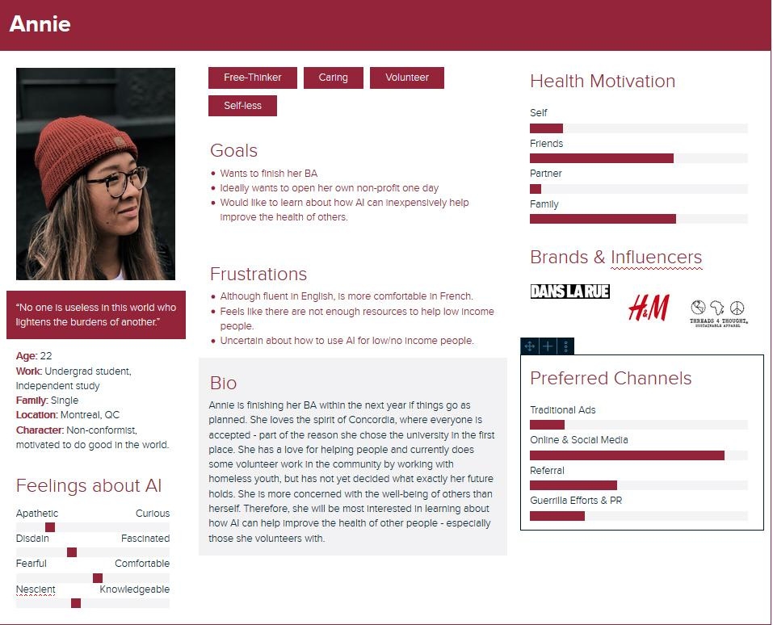
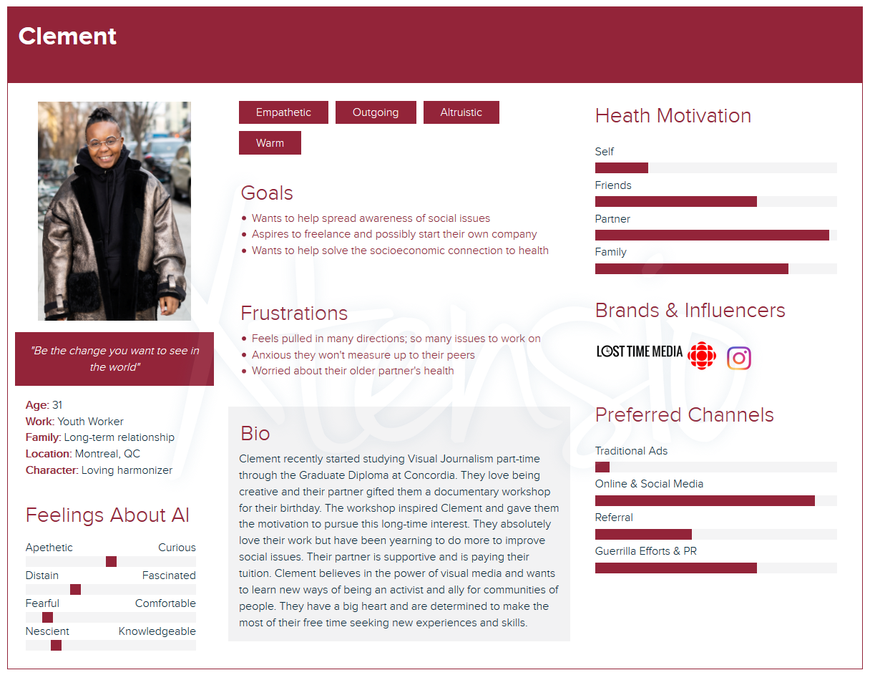
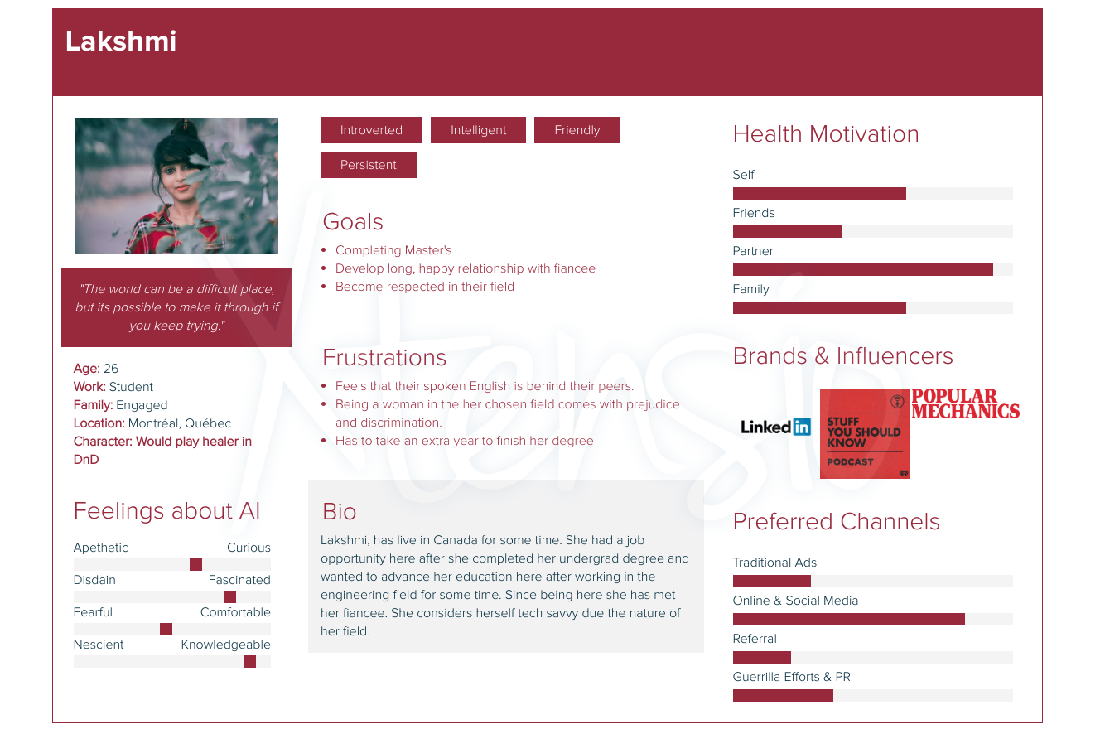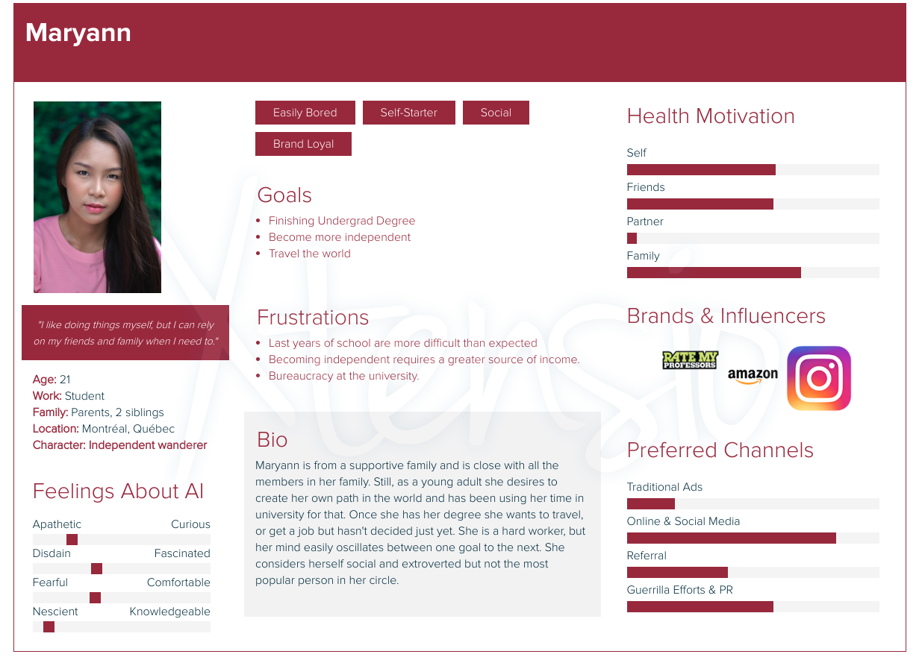
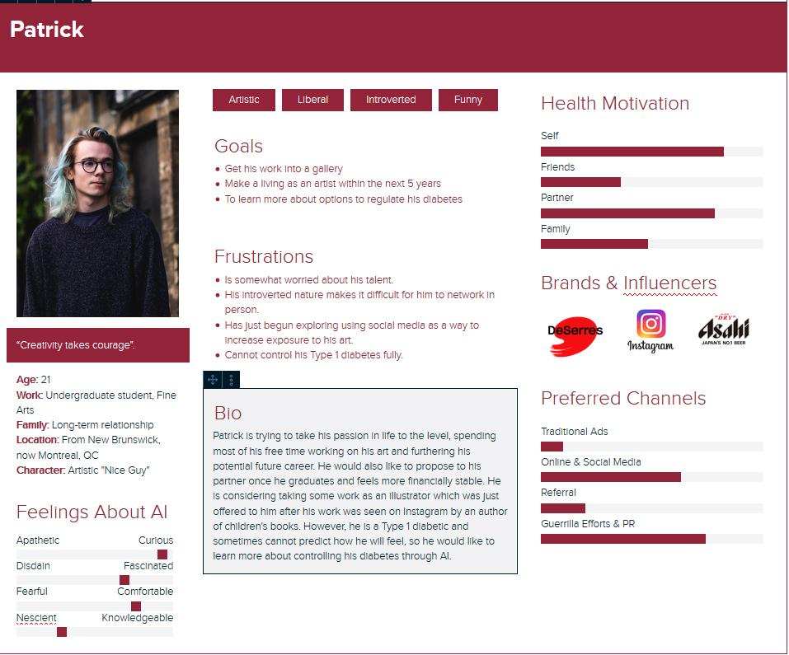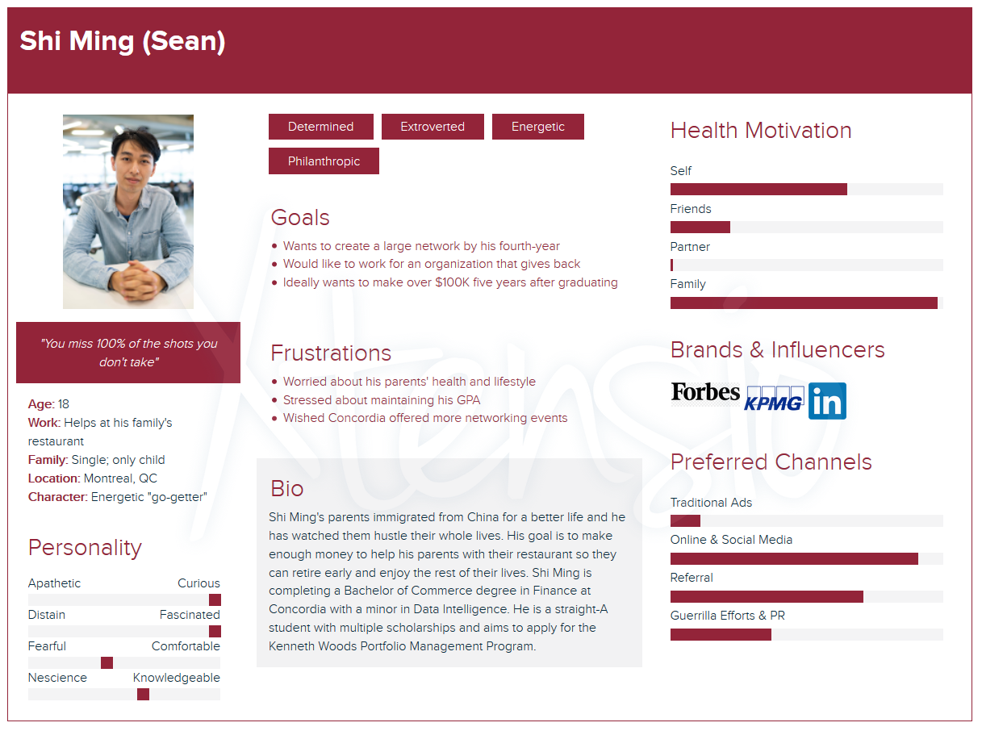

Storyboard
Slide Name: Explore AI as Your Health Ally  Date: February 2, 2020 Version: 1.0 | Project Title: Explore AI and Your Health |  | Slide #: 1
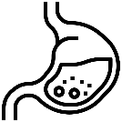  Explore AI as Your Health Ally  Text about AI as an Ally for the student’s health… |  |  | Slide links to:  1.1  1.2  1.3  1.4
Slide transition effect:
☑️ Straight cut
☐ Dissolve
☐Other

Animation details:
Clicking on each organ(s) creates a pop-up in the designated text area – or brings to new side. Once each organ has been clicked, a text box with instructions will pop-up to direct them back to Didacte.

Video details:
N/A

Audio details:
☐ Music
☐ Narration
☑️ Other – sounds for clicking organs; ambient music/sounds for each organ slide

Navigation Type: ☐ Buttons ☑️ Images ☐ Other –

Organ icons made by Surang from www.flaticon.com; human silhouette icon made by Freepik from www.flaticon.com
Slide Name: AI and Your Brain  Date: February 2, 2020 Version: 1.0 |  | Project Title: Explore AI and Your Health |  | Slide #: 1.1
  Got it!  AI and Your Brain  Text about how AI can be used to monitor or develop their brain health (sleep, agility, mental health)… |  |  |  | Slide links to:  1
Slide transition effect:
☑️ Straight cut
☐ Dissolve
☐Other

Animation details:
Clicking on each organ brings them to the corresponding slide. Once each organ has been clicked, a text box with instructions will pop-up to direct them back to Didacte.

Video details:
N/A

Audio details:
☐ Music
☐ Narration
☑️ Other – sounds for clicking organs; ambient music/sounds for each organ slide

Navigation Type: ☑️ Buttons ☑️ Images ☐ Other –

Organ icons made by Surang from www.flaticon.com; human silhouette icon made by Freepik from www.flaticon.com

Slide Name: AI and Your Heart  Date: February 2, 2020 Version: 1.0 | Project Title: Explore AI and Your Health | Slide #: 1.2
  Got it!  AI and Your Heart  Text about how AI can be used to monitor or develop their heart health (exercise)… |  | Slide links to:  1
Slide transition effect:
☑️ Straight cut
☐ Dissolve
☐Other

Animation details:
Clicking on each organ brings them to the corresponding slide. Once each organ has been clicked, a text box with instructions will pop-up to direct them back to Didacte.

Video details:
N/A

Audio details:
☐ Music
☐ Narration
☑️ Other – sounds for clicking organs; ambient music/sounds for each organ slide

Navigation Type: ☑️ Buttons ☑️ Images ☐ Other –

Organ icons made by Surang from www.flaticon.com; human silhouette icon made by Freepik from www.flaticon.com

Slide Name: AI and Your Stomach  Date: February 2, 2020 Version: 1.0 | Project Title: Explore AI and Your Health | Slide #: 1.3
  Got it!  AI and Your Stomach  Text about how AI can be used to monitor or develop their stomach health (nutrition, IBD)… |  | Slide links to:  1
Slide transition effect:
☑️ Straight cut
☐ Dissolve
☐Other

Animation details:
Clicking on each organ brings them to the corresponding slide. Once each organ has been clicked, a text box with instructions will pop-up to direct them back to Didacte.

Video details:
N/A

Audio details:
☐ Music
☐ Narration
☑️ Other – sounds for clicking organs; ambient music/sounds for each organ slide

Navigation Type: ☑️ Buttons ☑️ Images ☐ Other –

Organ icons made by Surang from www.flaticon.com; human silhouette icon made by Freepik from www.flaticon.com

Slide Name: AI and Your Genitals  Date: February 2, 2020 Version: 1.0 | Project Title: Explore AI and Your Health | Slide #: 1.4
  Got it!  AI and Your Genitals  Text about how AI can be used to monitor or develop their sexual health (reproduction/menstruation, STIs)… |  | Slide links to:  1
Slide transition effect:
☑️ Straight cut
☐ Dissolve
☐Other

Animation details:
Clicking on each organ brings them to the corresponding slide. Once each organ has been clicked, a text box with instructions will pop-up to direct them back to Didacte.

Video details:
N/A

Audio details:
☐ Music
☐ Narration
☑️ Other – sounds for clicking organs; ambient music/sounds for each organ slide

Navigation Type: ☑️ Buttons ☑️ Images ☐ Other –

Organ icons made by Surang from www.flaticon.com; human silhouette icon made by Freepik from www.flaticon.com

Slide Name: AI and Your Overall Health  Date: February 2, 2020 Version: 1.0 | Project Title: Explore AI and Your Health | Slide #: 1.1
Got it!  AI and Your Overall Health  Text about how AI can be used to monitor or develop their overall health… |  | Slide links to:  1
Slide transition effect:
☑️ Straight cut
☐ Dissolve
☐Other

Animation details:
Clicking on each organ brings them to the corresponding slide. Once each organ has been clicked, a text box with instructions will pop-up to direct them back to Didacte.

Video details:
N/A

Audio details:
☐ Music
☐ Narration
☑️ Other – sounds for clicking organs; ambient music/sounds for each organ slide

Navigation Type: ☑️ Buttons ☑️ Images ☐ Other –

Organ icons made by Surang from www.flaticon.com; human silhouette icon made by Freepik from www.flaticon.com

Slide Name: Explore AI as Your Health Ally  Date: February 2, 2020 Version: 1.0 | Project Title: Explore AI and Your Health | Slide #: 1 (after)
Text to close the module – option to close the browser to return to Didacte or exit this message (X) to continue exploring.  Explore AI as Your Health Ally  Text about AI as an Ally for the student’s health… |  | Slide links to:  1.1  1.2  1.3  1.4
Slide transition effect:
☑️ Straight cut
☐ Dissolve
☐Other

Animation details:
Clicking on each organ brings them to the corresponding slide. Once each organ has been clicked, a text box with instructions will pop-up to direct them back to Didacte.

Video details:
N/A

Audio details:
☐ Music
☐ Narration
☑️ Other – sounds for clicking organs; ambient music/sounds for each organ slide
Navigation Type: ☑️ Buttons ☑️ Images ☐ Other –

Organ icons made by Surang from www.flaticon.com; human silhouette icon made by Freepik from www.flaticon.com

Information Architecture

