

Decolonizing & Indigenizing the Curriculum

High-Level Design
Prepared by Megan Clare


Overview
This document outlines the high-level design of ten interventions for the campaign “Decolonizing & Indigenizing the Curriculum”. Ontario’s Ministry of Education is sponsoring the development of these initiatives. While community members, students, and all employees from the school to the Ministry should be considered performers, these interventions focus on teachers. However, five interventions include these broader types of performers.
Throughout the document “performers” will refer to teachers and “individuals” will refer to broader types of performers.
These ten interventions will help teachers reach the following performance objectives:
- Apply the narrative reflection and assessment process to dismantle colonial narratives within the curriculum
- Assess subjects by following curriculum guidelines to identify subjects that can be Indigenized
- Collaborate with colleagues and administrators to create events for topics involving lived experiences
- Create an instructional plan for the year based on the narratives, guidelines, and events
- Reflect on the success of the plan throughout the year

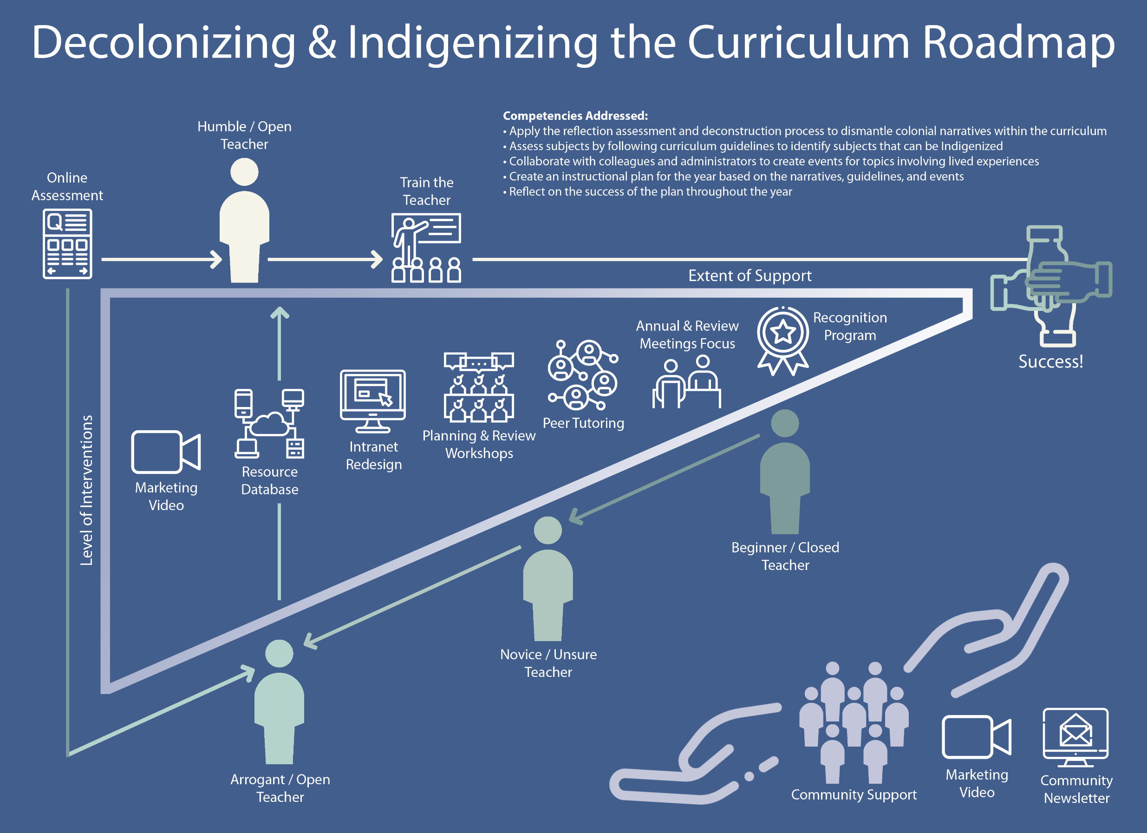
Online Assessment
Target Audience | Performance Phase(s) | Performance Need(s) | Form | Medium | Writing Style | Cost to Develop | Cost to Maintain
Performers | All | Knowledge/Skill | Quiz | Online Simple | Informal | High | Low
Performance Objective(s) | - Apply the narrative reflection and assessment process to dismantle colonial narratives within the curriculum  - Assess subjects by following curriculum guidelines to identify subjects that can be Indigenized  - Collaborate with colleagues and administrators to create events for topics involving lived experiences  - Create an instructional plan for the year based on the narratives, guidelines, and events  - Reflect on the success of the plan throughout the year
Intervention Description | A yearly online assessment will be developed and emailed to all employees of the school boards. The assessment will measure everyone’s level of knowledge, skills, attitudes, and biases towards decolonizing and indigenizing the curriculum. It will help identify everyone’s needs and will allow opportunities to be easily curated for them.
Audience Expectations | That the assessment will be user friendly and take minimal time to complete.
Benefits | The online communication medium provides inexpensive hosting and distribution. Employee completion will be easily tracked, and reminder emails can be automated. Employees will be able to access it from any internet-connected device. Employees will be comfortable with the quiz-like format and will require minimal assistance to complete it.

Resource Database
Target Audience | Performance Phase(s) | Performance Need(s) | Form | Medium | Writing Style | Cost to Develop | Cost to Maintain
Performers & Individuals | All | Knowledge/Skill  Resources  Motivation | Database | Online Complex | Informal | High | Moderate
Performance Objective(s) | - Apply the narrative reflection and assessment process to dismantle colonial narratives within the curriculum  - Assess subjects by following curriculum guidelines to identify subjects that can be Indigenized  - Collaborate with colleagues and administrators to create events for topics involving lived experiences  - Create an instructional plan for the year based on the narratives, guidelines, and events  - Reflect on the success of the plan throughout the year
Intervention Description | The new database will be accessible from the board intranets and will be searchable based on subject, goal, and grade level. Current resources will be added by administrators and future resources may be submitted by anyone by vetted by administrators. The resources will be a mix of student activities, books for students and teachers, videos, podcasts, job aids, and more.
Audience Expectations | Intuitive and user-centered design that returns relevant, high-quality resources that can be access from the database.  Know who to contact if have questions or need assistance with the resources.
Benefits | Resources are currently scarce and usually involve following external links. The intranet is not user-friendly and adds to the frustration of accessing provided resources. The database will ensure teachers use approved, high-quality resources and activities that are specific to their local community. Creating a simple, convenient experience for teachers should help with their motivation. There will be a large cost to build the database, but maintenance will be moderate.

Intranet Redesign
Target Audience | Performance Phase(s) | Performance Need(s) | Form | Medium | Writing Style | Cost to Develop | Cost to Maintain
Performers & Individuals | All | Motivation | Intranet | Online Complex | Informal | High | Low
Performance Objective(s) | - Apply the narrative reflection and assessment process to dismantle colonial narratives within the curriculum  - Assess subjects by following curriculum guidelines to identify subjects that can be Indigenized  - Collaborate with colleagues and administrators to create events for topics involving lived experiences  - Create an instructional plan for the year based on the narratives, guidelines, and events  - Reflect on the success of the plan throughout the year
Intervention Description | The intranet will be redesigned to improve teacher use and access to the resource database. A UX consultant will be hired and the plans will be given to the developer.
Audience Expectations | An intuitive, user-centered intranet.
Benefits | The redesign will require high cost and time to develop but maintenance will be low. The redesign will improve teachers’ use of the intranet and will promote use of provided resources.

Marketing Video
Target Audience | Performance Phase(s) | Performance Need(s) | Form | Medium | Writing Style | Cost to Develop | Cost to Maintain
Performers & Individuals | All | Knowledge/Skill  Motivation | Advertisement | Video | Informal | High | Low
Performance Objective(s) | - Apply the narrative reflection and assessment process to dismantle colonial narratives within the curriculum  - Assess subjects by following curriculum guidelines to identify subjects that can be Indigenized  - Collaborate with colleagues and administrators to create events for topics involving lived experiences  - Create an instructional plan for the year based on the narratives, guidelines, and events  - Reflect on the success of the plan throughout the year
Intervention Description | Three versions of a promotion video will be created for employees, parents, and students to explain the initiative and benefit of it. The videos will be geared to elementary school, middle school, and high school to encompass all grade levels. The high school version will be sent to teachers and parents along with the versions for their children.
Audience Expectations | An interesting, engaging, short video.
Benefits | The video will require high time and cost to develop but minimal time and cost to maintain. It will help introduce the initiative to everyone involved and reduce the burden of explanation on teachers.

Train the Teacher
Target Audience | Performance Phase(s) | Performance Need(s) | Form | Medium | Writing Style | Cost to Develop | Cost to Maintain
Performers | Humble | Knowledge/Skill  Resources | Lecture/ Webinar | In-Person  Online Mix | Informal | High | Moderate
Performance Objective(s) | - Apply the narrative reflection and assessment process to dismantle colonial narratives within the curriculum  - Assess subjects by following curriculum guidelines to identify subjects that can be Indigenized  - Collaborate with colleagues and administrators to create events for topics involving lived experiences  - Create an instructional plan for the year based on the narratives, guidelines, and events  - Reflect on the success of the plan throughout the year
Intervention Description | Leaders identified through the assessment will be given the opportunity to be trained to run the yearly workshops and train further teachers who reach the humble phase. Refresher trainings will be provided.
Audience Expectations | To be provided with the knowledge/skill and practice to be confident in their abilities and comfortable training others.
Benefits | The high costs to set-up the program will minimize future costs by creating a self-sustaining system over time. It also provides motivation for teachers who aim to become a leader. The remaining cost will be for administrator hours in coordinating future training and updating materials.

Peer-Mentoring Program
Target Audience | Performance Phase(s) | Performance Need(s) | Form | Medium | Writing Style | Cost to Develop | Cost to Maintain
Performers | All | Knowledge/Skill  Resources  Motivation | Coaches | In-Person  Online Simple  Mobile | Informal | Moderate | Low
Performance Objective(s) | - Apply the narrative reflection and assessment process to dismantle colonial narratives within the curriculum  - Assess subjects by following curriculum guidelines to identify subjects that can be Indigenized  - Collaborate with colleagues and administrators to create events for topics involving lived experiences  - Create an instructional plan for the year based on the narratives, guidelines, and events  - Reflect on the success of the plan throughout the year
Intervention Description | An optional peer-mentoring program to increase knowledge/skill transfer and human resources. The online assessment will identify employees who are capable of being leaders (mentors) to market the opportunity to them, and market the program to the others. Employees will be paired based on their assessments and preferences for communication, location, or a specific person.
Audience Expectations | To have a positive experience and that the mentors will be competent in their abilities.
Benefits | The main cost for the program will be in administrator hours which will reduce after the initial launch. The convenience of having a colleague to work with will help reduce mental barriers. The program will also affect employees’ motivations if they aim to become a leader. The ease of enrollment and convenience will attract and retain employees in the program.

Yearly Planning & Reflection Workshops
Target Audience | Performance Phase(s) | Performance Need(s) | Form | Medium | Writing Style | Cost to Develop | Cost to Maintain
Performers | All | Knowledge/Skill  Resources  Motivation | Workshop | In-Person | Informal | High | Low
Performance Objective(s) | - Apply the narrative reflection and assessment process to dismantle colonial narratives within the curriculum  - Assess subjects by following curriculum guidelines to identify subjects that can be Indigenized  - Collaborate with colleagues and administrators to create events for topics involving lived experiences  - Create an instructional plan for the year based on the narratives, guidelines, and events  - Reflect on the success of the plan throughout the year
Intervention Description | Each school or cluster of schools will hold yearly planning workshops before the school year and reflection workshops after the school year. Initially, consultants will be hired to moderate these workshops. Over time, Teacher Leaders will be trained to run these independently. For complex or new situations, consultants will be brought in.
Audience Expectations | A great level of help and clarity for their plan and reflection.
Benefits | The workshops will simplify the process for teachers by providing as much assistance or review as they need in creating their year plan and reflecting on its success. It also provides an opportunity for leaders to continue to develop their capabilities. The workshops will reduce mental barriers by alleviating any uncertainties and checking arrogant confidence. The set-up cost is high due to the need for external consultants and training opportunities for leaders. As leaders become more capable, the consultants will be infrequently needed, and the workshops will become self-contained. The remaining cost will be for administrator hours in coordinating the meetings.

Annual Plan & Review Meeting Focus
Target Audience | Performance Phase(s) | Performance Need(s) | Form | Medium | Writing Style | Cost to Develop | Cost to Maintain
Performers | All | Motivation | Coaching | In-Person | Informal | None | None
Performance Objective(s) | - Apply the narrative reflection and assessment process to dismantle colonial narratives within the curriculum  - Assess subjects by following curriculum guidelines to identify subjects that can be Indigenized  - Collaborate with colleagues and administrators to create events for topics involving lived experiences  - Create an instructional plan for the year based on the narratives, guidelines, and events  - Reflect on the success of the plan throughout the year
Intervention Description | Principles will discuss and suggest relevant goals during these meetings to help increase motivation. If the principle of a school is not at a high enough phase, a leader will be tasked with setting a separate meeting to check-in on their goals.
Audience Expectations | For professional development choices to remain autonomous.
Benefits | The discussion and suggestions will help encourage teachers at all phases to continue their progression. It also provides and opportunity for additional attention on the resistant teachers. As these meetings already take place, there will be no added costs associated with this intervention. Continued training of all employees will help more principles reach competency.

Monthly Recognition Program & eNewsletter
Target Audience | Performance Phase(s) | Performance Need(s) | Form | Medium | Writing Style | Cost to Develop | Cost to Maintain
Performers & Individuals | All | Motivation | eNewsletter | Online Simple | Informal | Low | Moderate
Performance Objective(s) | - Apply the narrative reflection and assessment process to dismantle colonial narratives within the curriculum  - Assess subjects by following curriculum guidelines to identify subjects that can be Indigenized  - Collaborate with colleagues and administrators to create events for topics involving lived experiences  - Create an instructional plan for the year based on the narratives, guidelines, and events  - Reflect on the success of the plan throughout the year
Intervention Description | A monthly enewsletter per board will be emailed to employees highlighting ideal performers in all positions and at every performance phase.
Audience Expectations | A high level of transparency and fairness.
Benefits | By including each role and phase, all employees will know they have an opportunity to be featured. Employees will be able to nominate each other, and the nominations will be vetted by leaders, principles, and administrators. The form for nominations and enewsletter template will require minimal time and cost to develop. Maintenance costs are moderate and involve administrators time to evaluate nominations and create the enewsletters.

Quarterly Parents eNewsletter
Target Audience | Performance Phase(s) | Performance Need(s) | Form | Medium | Writing Style | Cost to Develop | Cost to Maintain
Individuals | All | Knowledge/Skill  Resources  Motivation | eNewsletter | Online Simple | Informal | Low | Moderate
Performance Objective(s) | - Apply the narrative reflection and assessment process to dismantle colonial narratives within the curriculum  - Assess subjects by following curriculum guidelines to identify subjects that can be Indigenized  - Collaborate with colleagues and administrators to create events for topics involving lived experiences  - Create an instructional plan for the year based on the narratives, guidelines, and events  - Reflect on the success of the plan throughout the year
Intervention Description | A quarterly enewsletter per board will be emailed to parents explaining the changes, addressing potential concerns, providing resources, and highlighting school-specific student accomplishments and opportunities.
Audience Expectations | A concise and well-designed email.
Benefits | The enewsletter will require moderate time and cost to develop and maintain. Multiple enewsletters can be drafted when administrators have lower work loads. Leaders will help create the content and tailor student accomplishments to each school.

Icon Credits
Chevron icon made by Dave Gandy from www.flaticon.com
Cloud server icon made by Eucalyp from www.flaticon.com
Conference, email, open hands, piled hands, ribbon icons made by Freepik from www.flaticon.com
Interview icon made by srip from www.flaticon.com
Lecture icon made by geotatah from www.flaticon.com
Network and website icons made by prettycons from www.flaticon.com
Questionnaire icon made by Smashicons from www.flaticon.com
Silhouette icon from www.clipart-library.com
Video icon made by Kiranshastry from www.flaticon.com

