

Decolonizing & Indigenizing the Curriculum
Resource Portal

Detailed Design
Prepared by Megan Clare


Table of Contents
Overview 3
Material to Develop 4
UX Planes Outline 4
Personas 7
Schema Diagram 13
Wireframes 14
Formative Assessment Plan 38
Summative Evaluation Plan 45
Appendix A 48
References 62

Overview
This document provides detailed design information for the intervention titled “Decolonizing & Indigenizing Resource Portal”. Ontario’s Ministry of Education is sponsoring the development of the portal for teachers to help them reach the following performance objectives:
- Apply the narrative reflection and assessment process to dismantle colonial narratives within the curriculum
- Assess subjects by following curriculum guidelines to identify subjects that can be Indigenized
- Create an instructional plan for the year based on the narratives, guidelines, and events
The portal will be accessible from the board intranets and will allow for customized branding. Current resources will be added by administrators and future resources may be submitted by anyone and vetted by administrators. The resources will be a mix of student activities, books for students and teachers, articles, videos, podcasts, job aids, and more.
This intervention takes the form of a database with and online complex medium. It will take six to twelve months to develop and will involve moderate maintenance costs.
The portal will ensure teachers use approved, high-quality resources and activities that are specific to their local community. Resources are currently scarce and usually involve following external links. The intranet is not user-friendly and adds to the frustration of accessing provided resources. Creating a simple, convenient experience for teachers should help with their motivation.

Material to Develop
The following sections provide detailed design guides for the developer and user experience (UX) specialist creating the portal. A UX planes outline provides the strategy for the UX specialist and includes the functional specifications, content requirements, and schema diagram for the developer.

UX Planes Outline
This section focuses on the UX strategy and supplemental documents for the portal. The chart below outlines the UX planes and is followed by personas, a schema diagram, and wireframes. The formative assessment and summative evaluation plans are referenced and follow this section in respective order.

Strategy Plane
User Needs  Full demographic information can be found in the Ontario College of Teachers’ 2018 Annual Report: https://www.oct.ca/about-the-college/annual-reports  Note: It does not contain any information on teachers’ ethnicities. The closest indication is the figure identifying how many teachers were certified outside of Canada and the U.S. However, this only allows for assumptions of the teachers’ ethnicities. Ontario teachers are predominantly white and there has been recent acknowledgement for the need for increased diversity (Ryan, J., Pollock, K., & Antonelli, F., 2009; Turner Consulting Group, 2015; Abawi, Z. E., 2018).  See Personas | Product Objectives  - Store and organize resources and metadata for teachers and Indigenous Leaders  - Allow search by board, grade, subject, unit, type, keywords, rating, date range  - Provide an intuitive UI  - Include different permissions based on the user’s role  Performance Objectives  - Apply the narrative reflection and assessment process to dismantle colonial narratives within the curriculum  - Assess subjects by following curriculum guidelines to identify subjects that can be Indigenized  - Create an instructional plan for the year based on the narratives, guidelines, and events  Business Objectives  Comply with regulations by increasing the ease of decolonizing and Indigenizing the curriculum for teachers  Brand Identity  Ontario Ministry of Education (default) and customizable for each school board  Success Metrics  See Formative Assessment & Summative Evaluation
Scope Plane
Functional Specifications  - Responsive Design (versions to be discussed)  - Android  - Google Chrome  - Firefox  - iphone  - Safari  - Google Chrome  - Web  - Google Chrome  - Firefox  - Safari  - Microsoft Edge  - Internet Explorer  - Accessible (http://www.edu.gov.on.ca/  eng/general/accessibility/  edu/1011/edu1011.pdf) | Content Requirements  User accounts with email, passwords, and the following features  - Indigenous Elders & Leaders, Professors, Teachers, Counselors, etc.  - Home with simple search  - Advanced Search  - New Resource Form  - Edit Resource Function  - Administrators  - Home with simple search  - Advanced Search  - New Resource Form  - Edit Resource Function  - New User Form  - Edit User Function  - Review List  - Settings Form
Structure & Skeleton Plane
Interaction Design & Interface Design  See Wireframes | Information Architecture & Navigation Design  See Schema Diagram
Surface Plane
The Decolonizing & Indigenizing Resource Portal should be able to be customized by administrators to Board-specific style guides, otherwise follow Ministry of Education.

Font: Verdana (regular), size 12 for body & hyperlinks, size 13 for section headings, size 14 for content headings
Ministry of Education logo – black or white, full logo
Colours:
- White ffffff
- White-green f5f9ed
- Yellow-green ecf3d2
- Light foam green e9f3d9
- Foam green c0d4a1
- Succulent green 92b8ab
- Khaki green 93ad6c
- Spruce green 1c413a
- Forest green 133e35
- Light grey c0c0c0
- Medium grey 868686
- Dark grey 333333
- Black-grey 444444

Personas
The six personas below were derived from the demographic data (Ontario College of Teachers, 2018) and different user roles. They include four teachers, a principle, and an administrator.
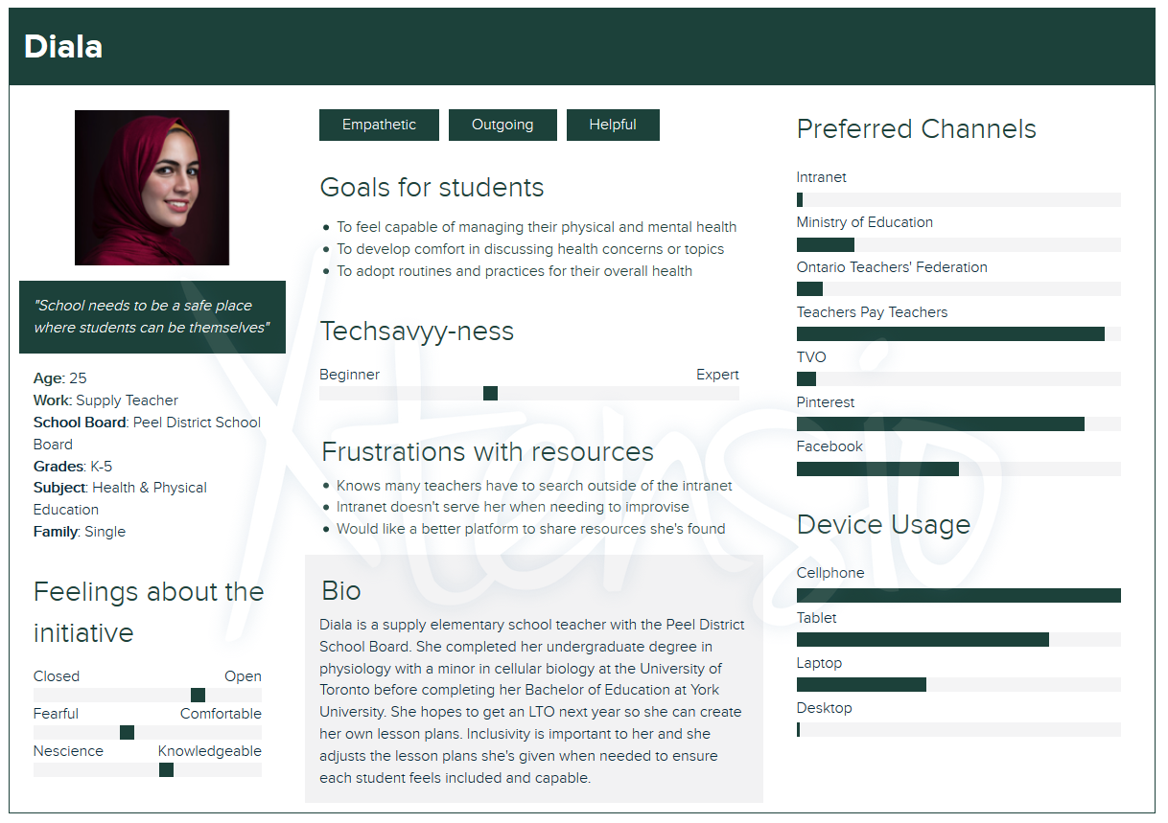

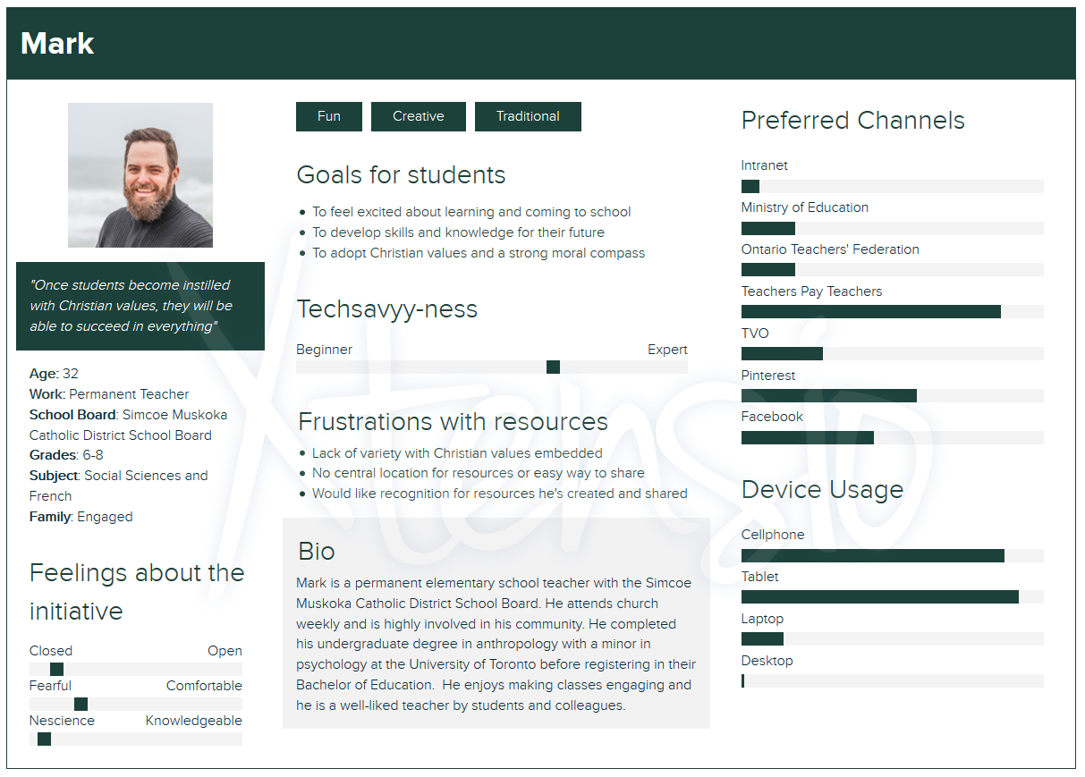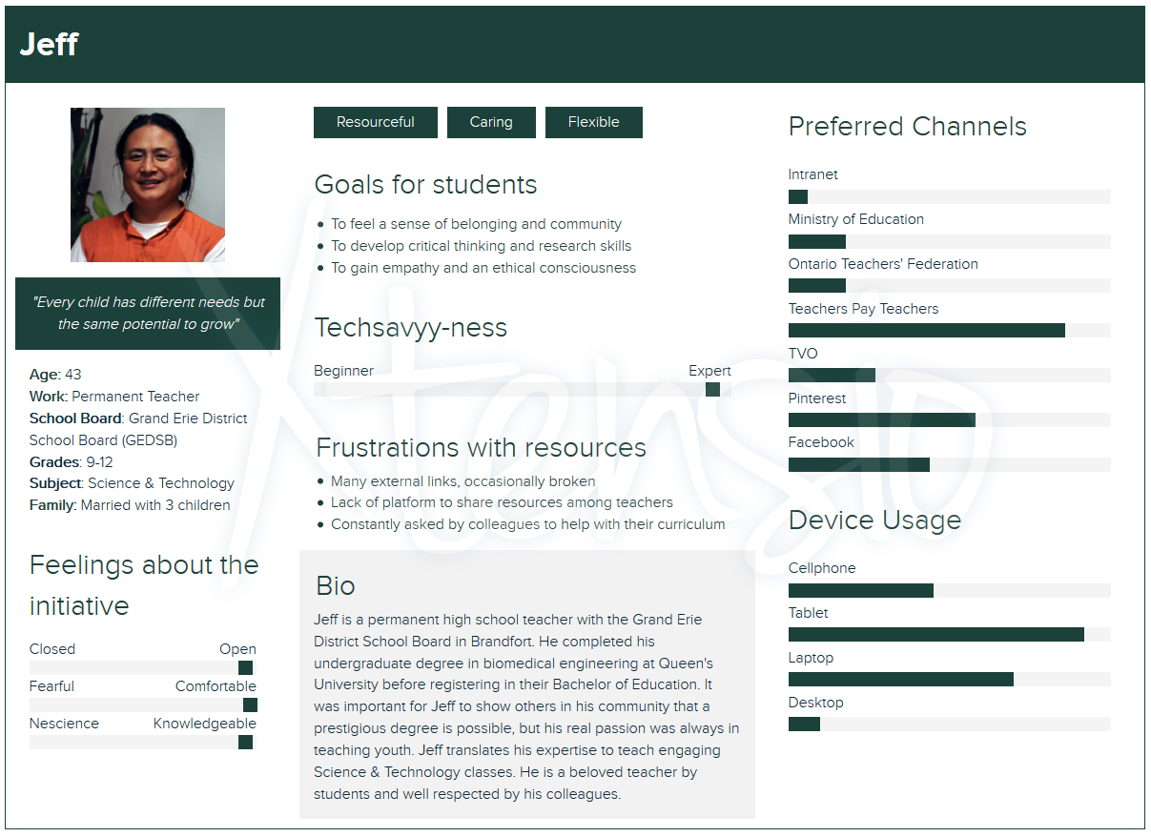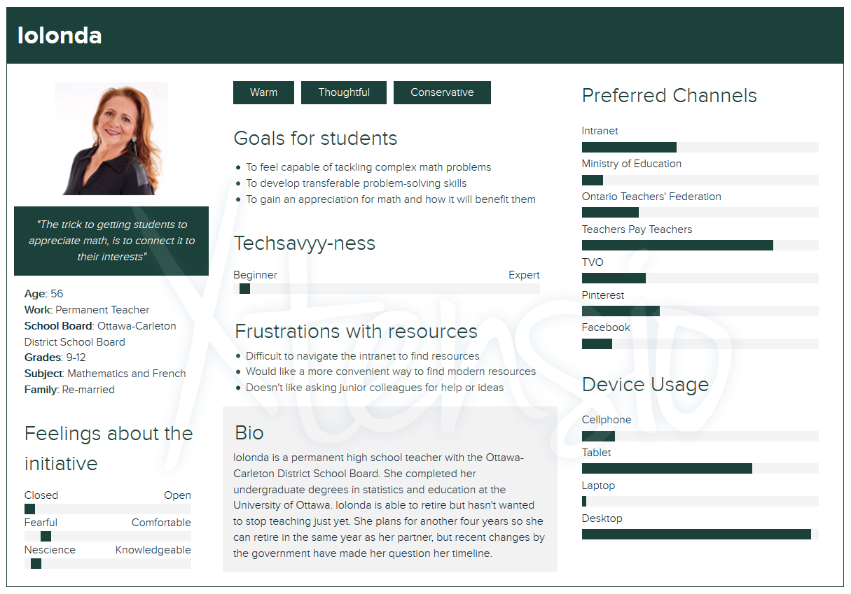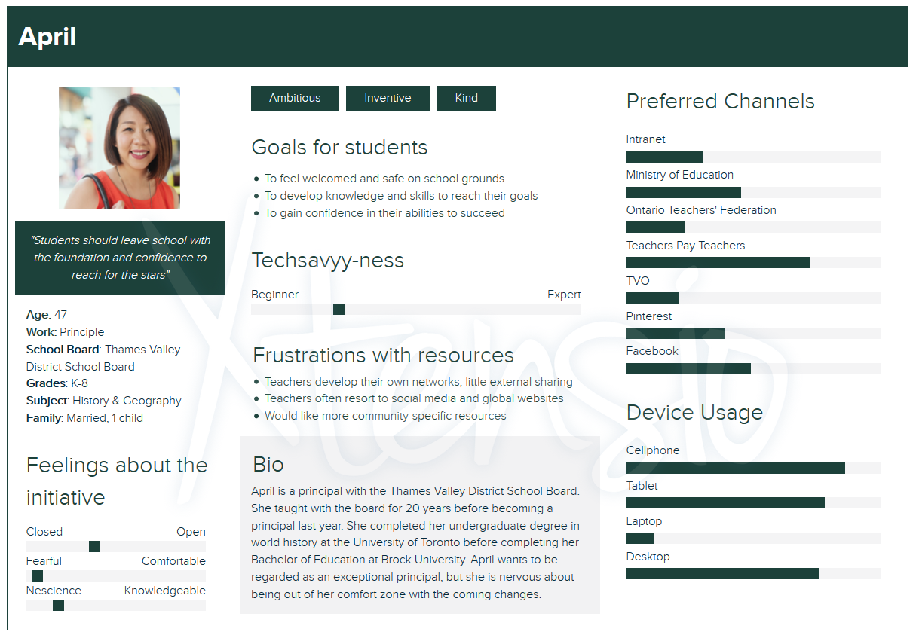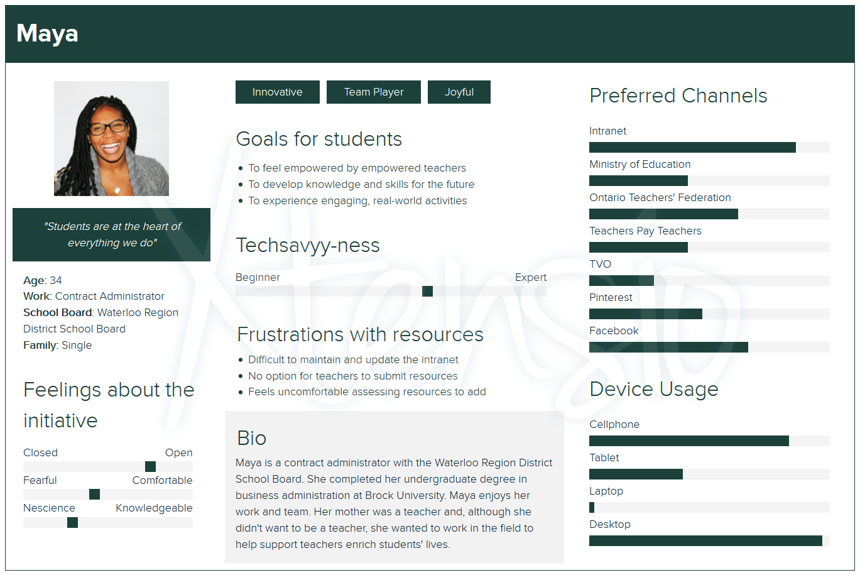

Schema Diagram

The diagram below provides the relationship tables for the back-end database. It was created with guidance from a Software Architect, Davide De Simone (personal communication, March 28, 2020).

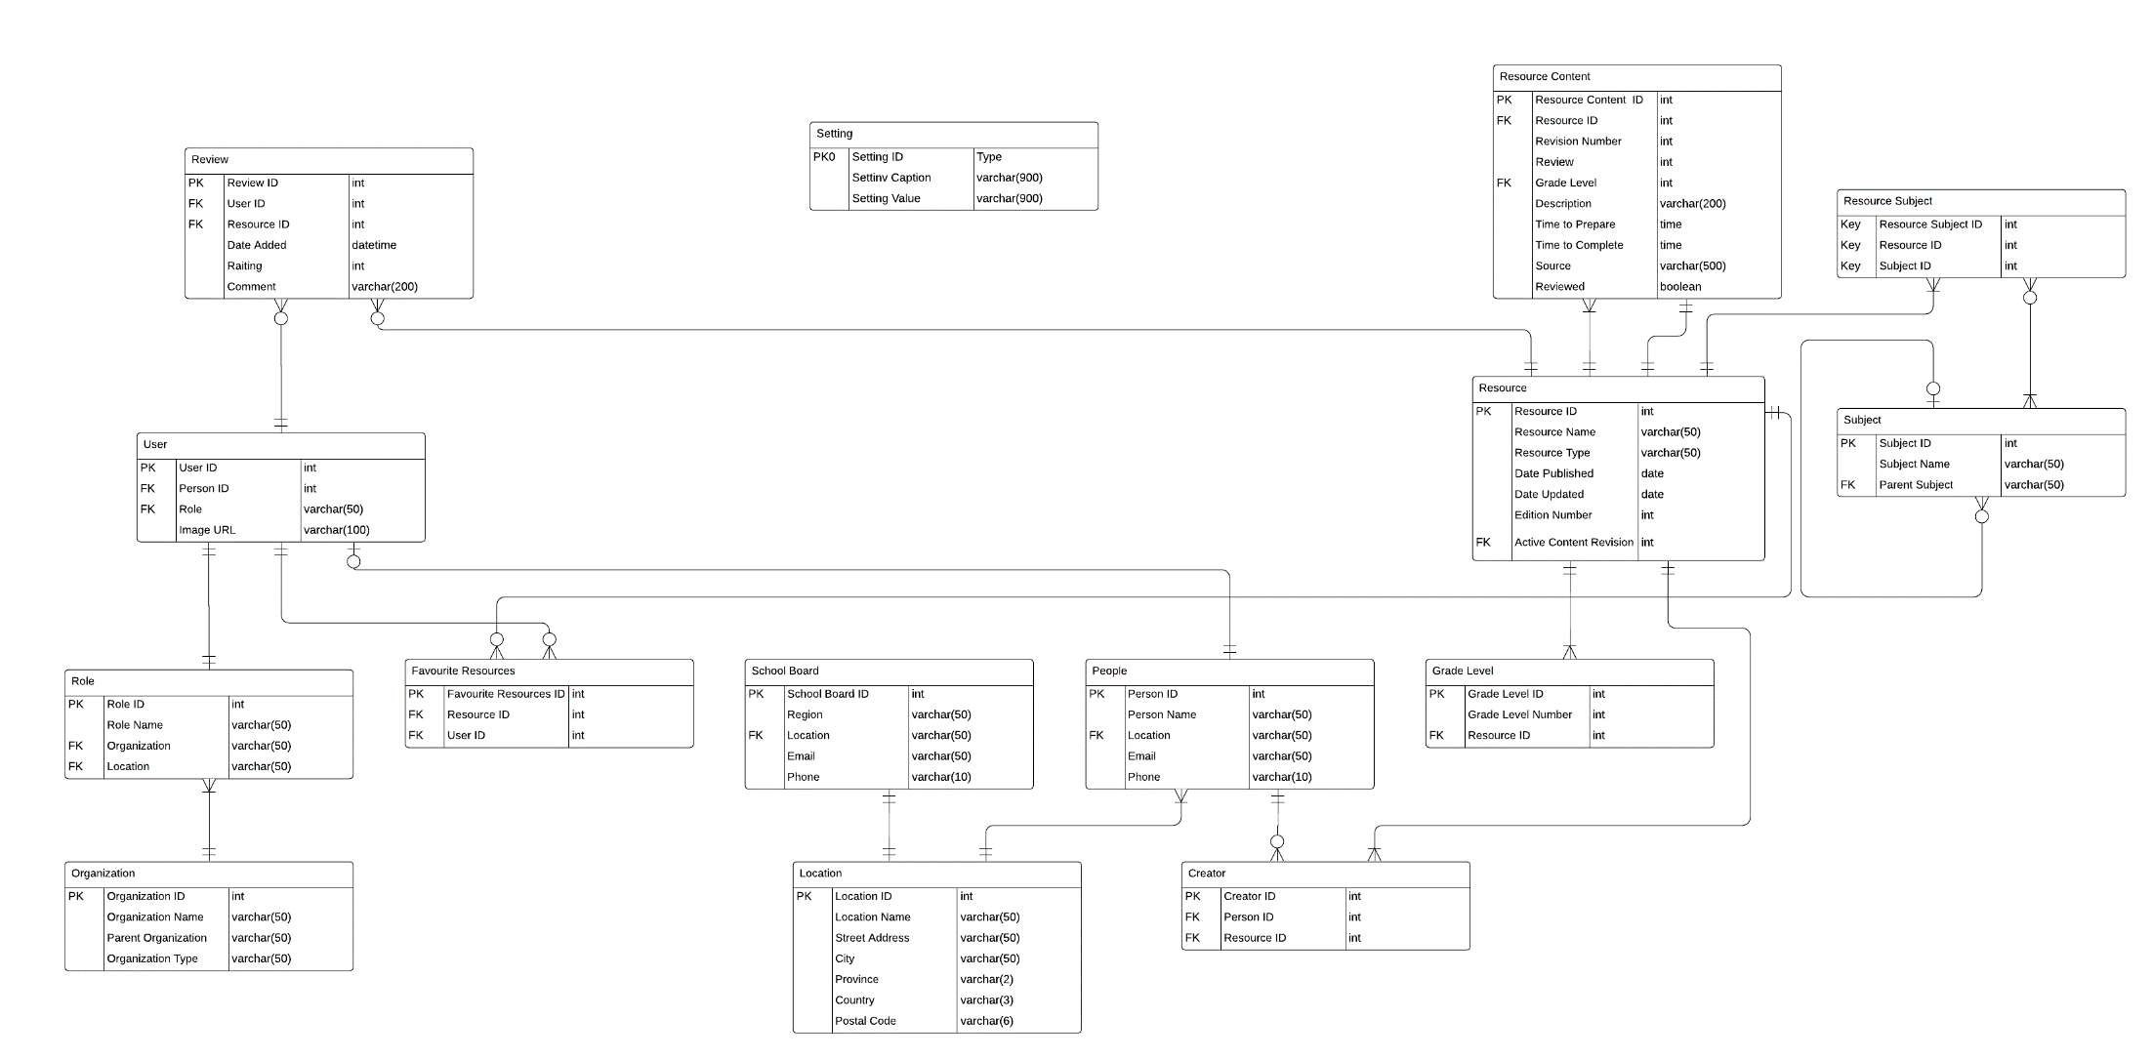

Wireframes
The wireframes below show users’ view for each section of the portal in web and mobile formats.

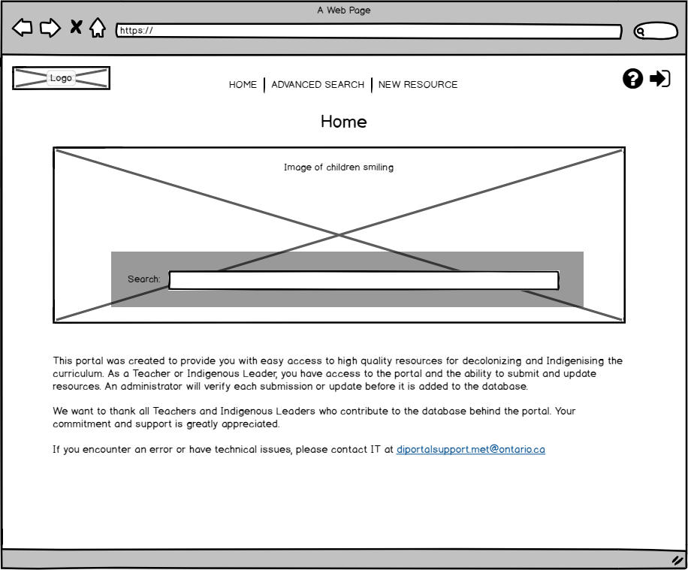

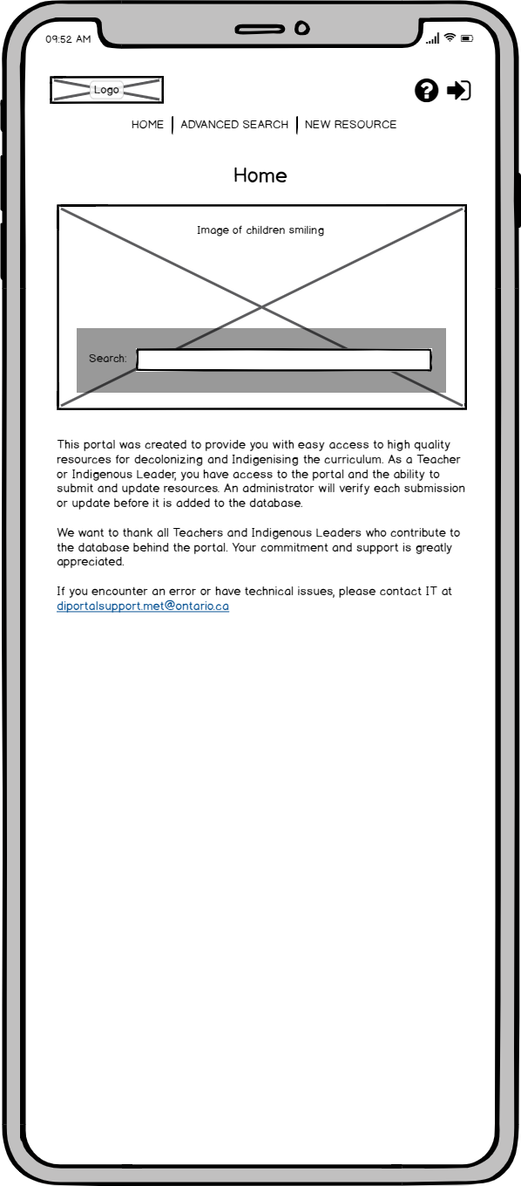

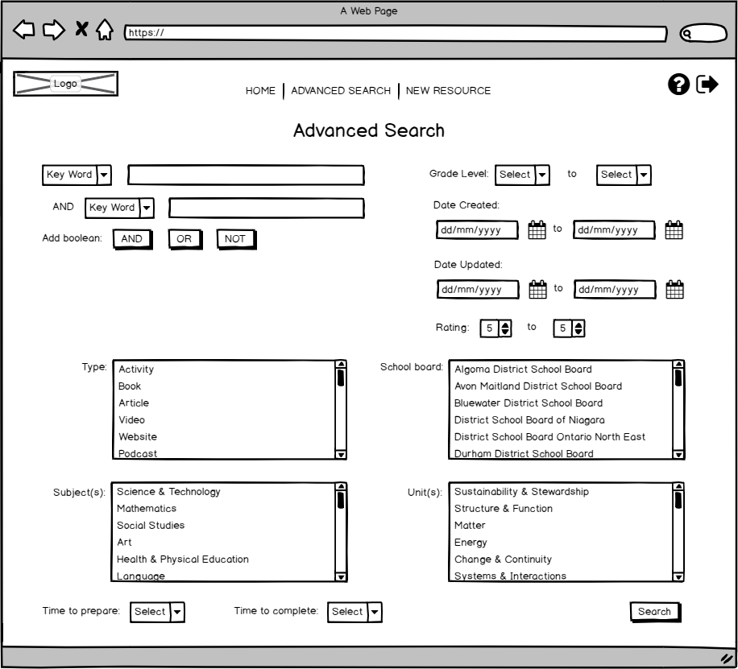

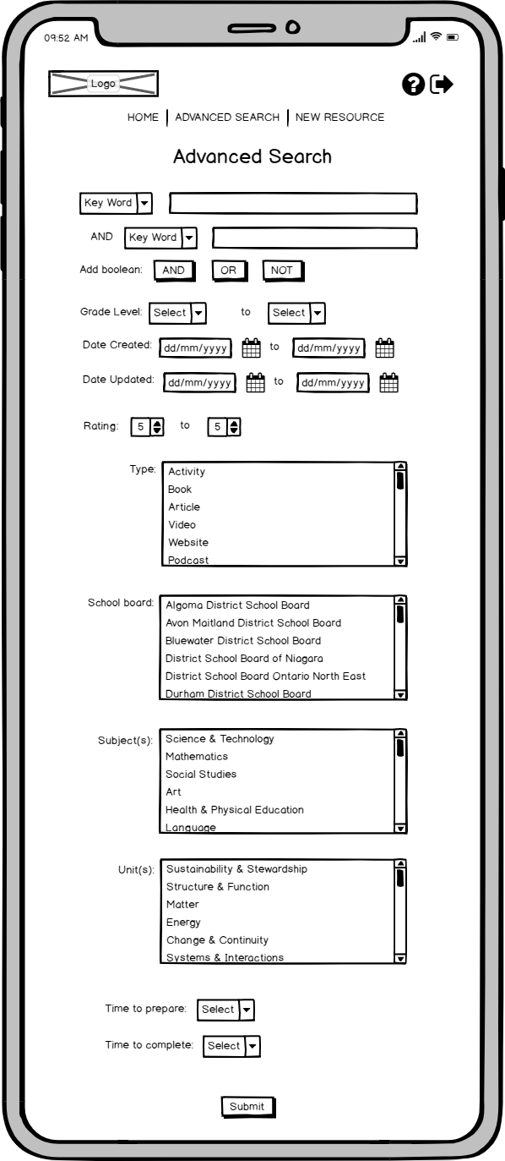
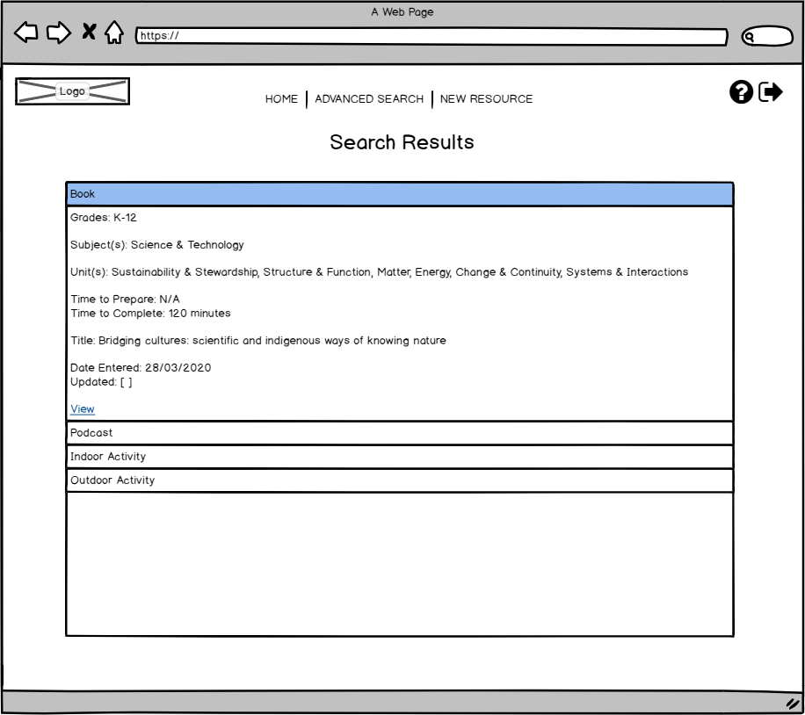

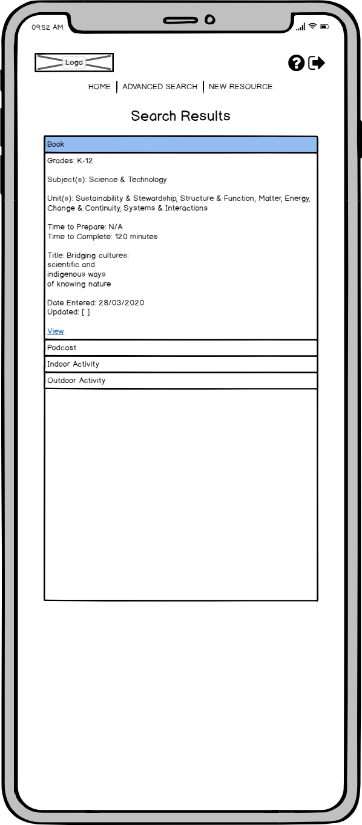
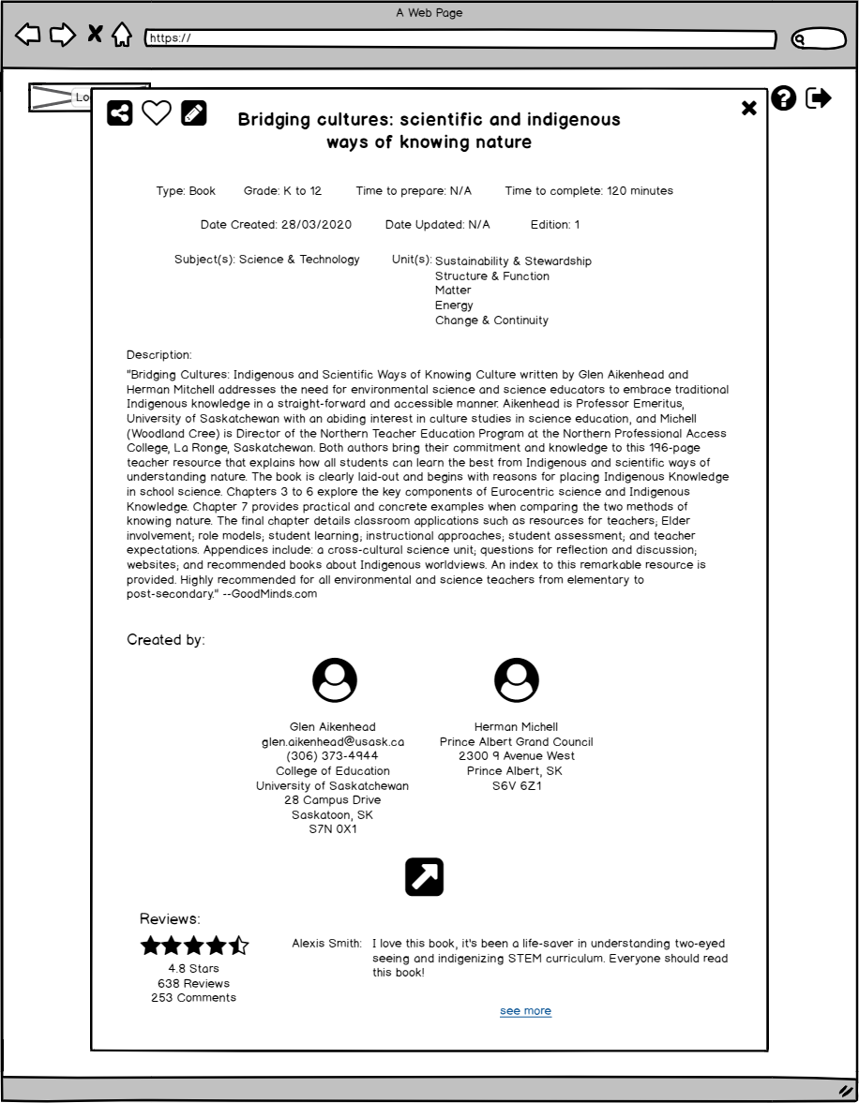

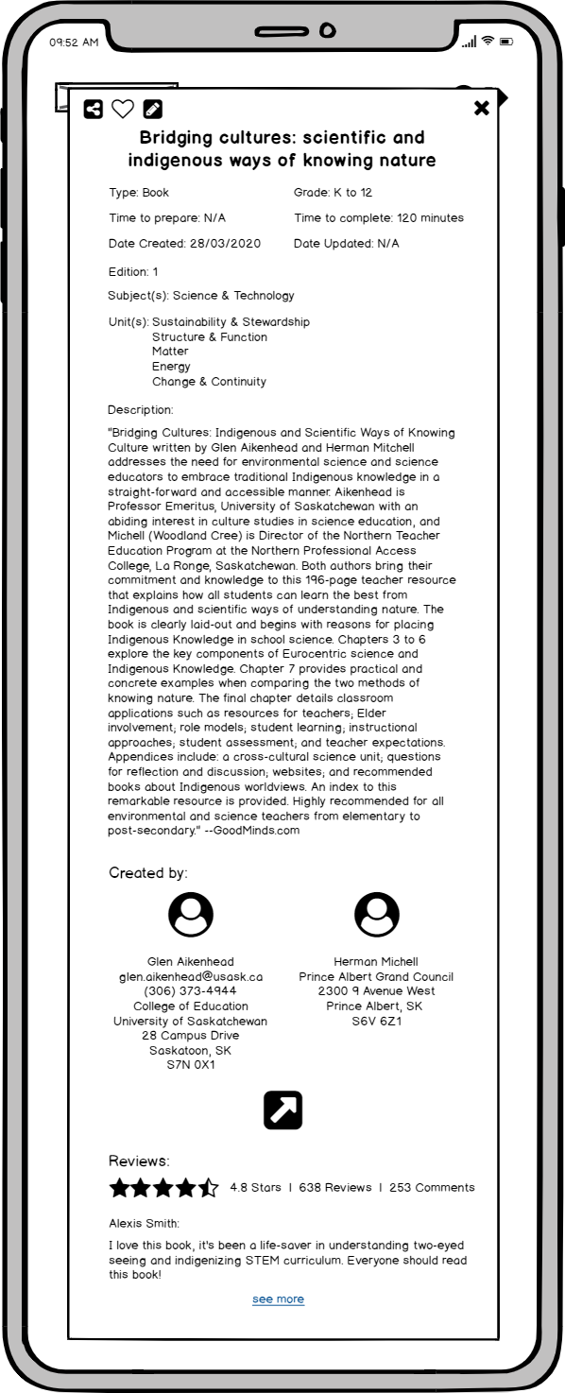
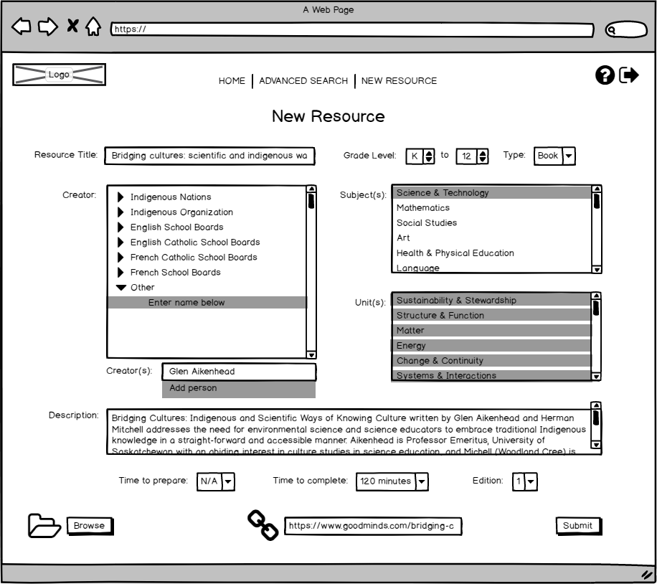

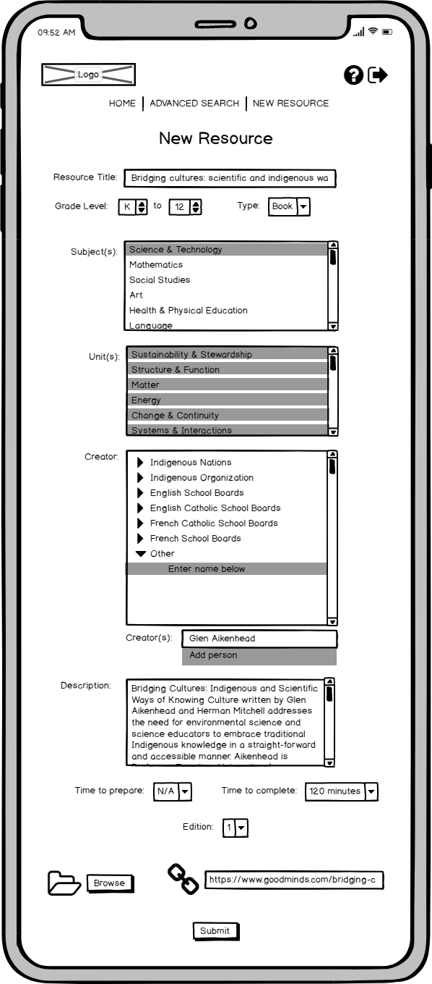
The wireframes below show views for the additional sections of the portal administrators have access to in web and mobile formats.

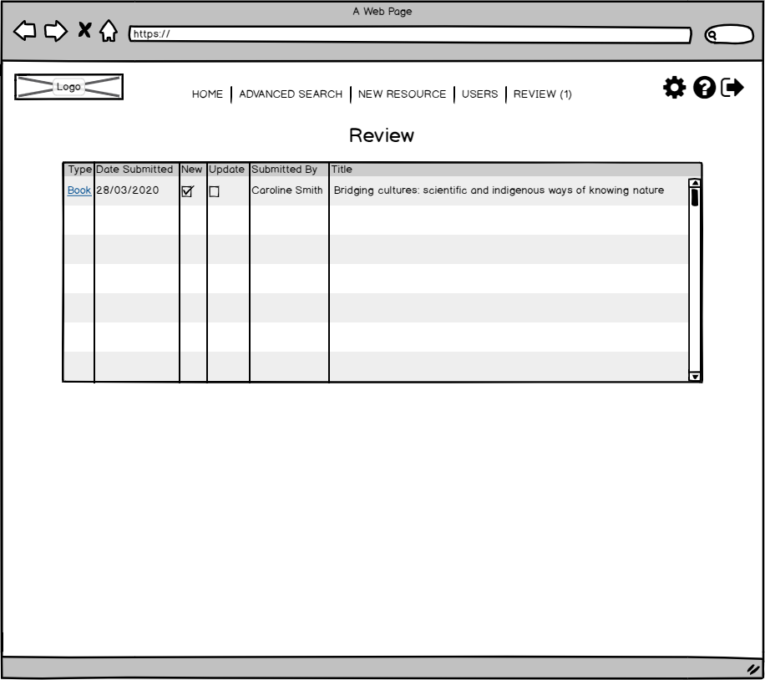
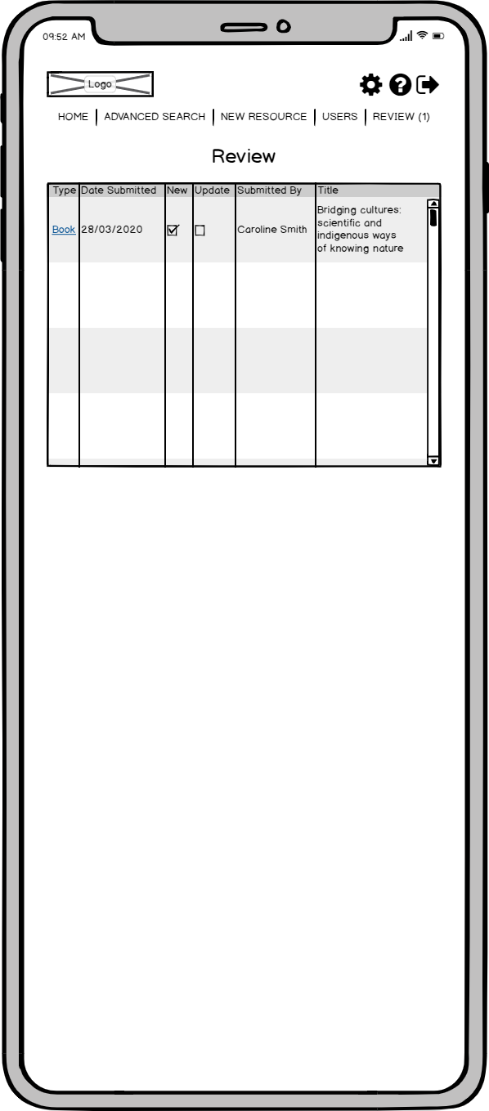
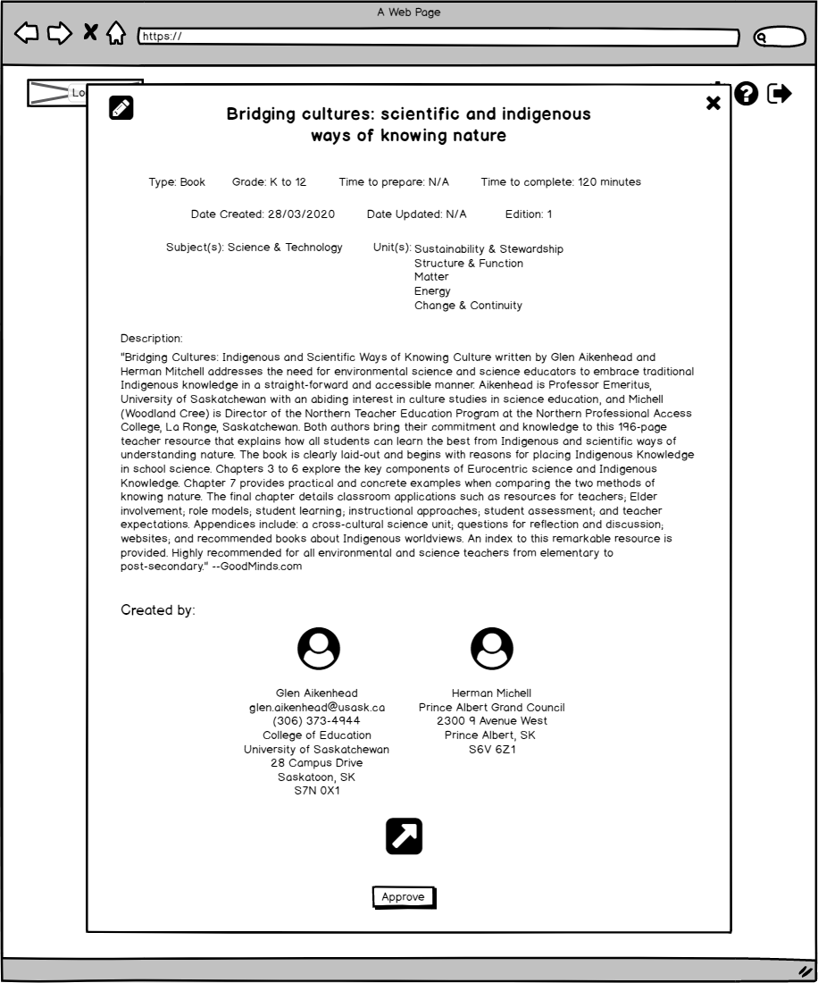
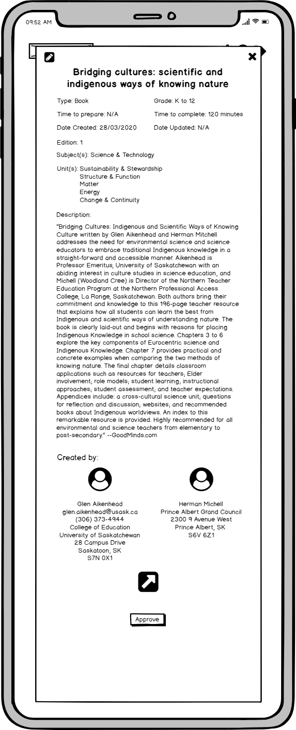
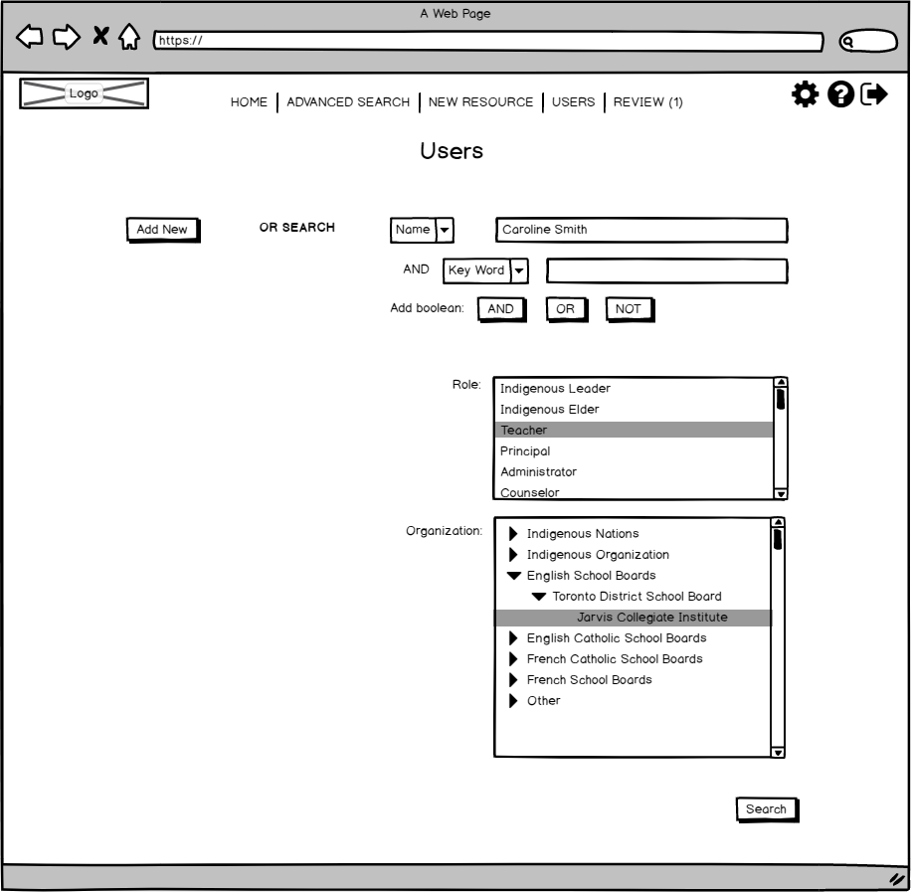

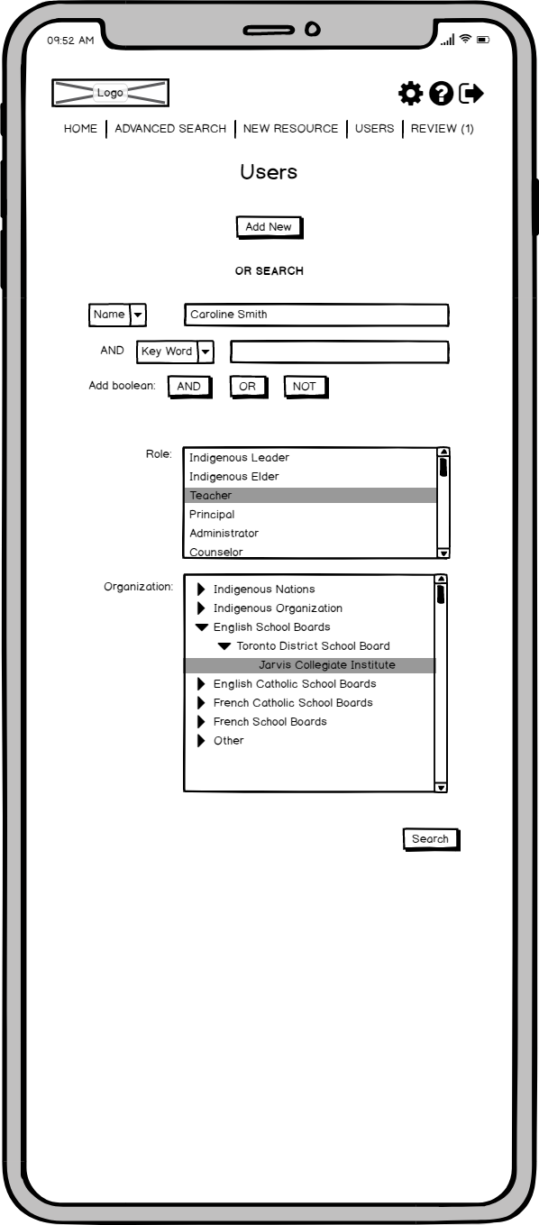

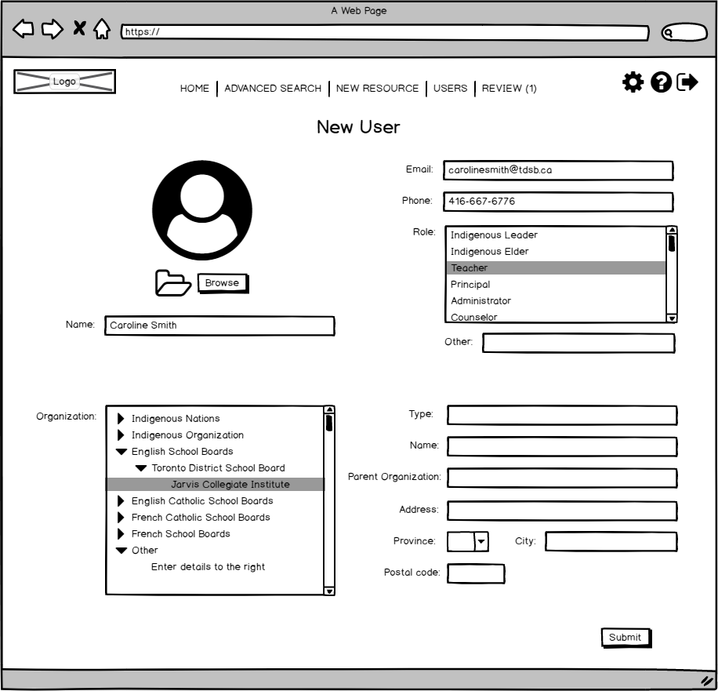

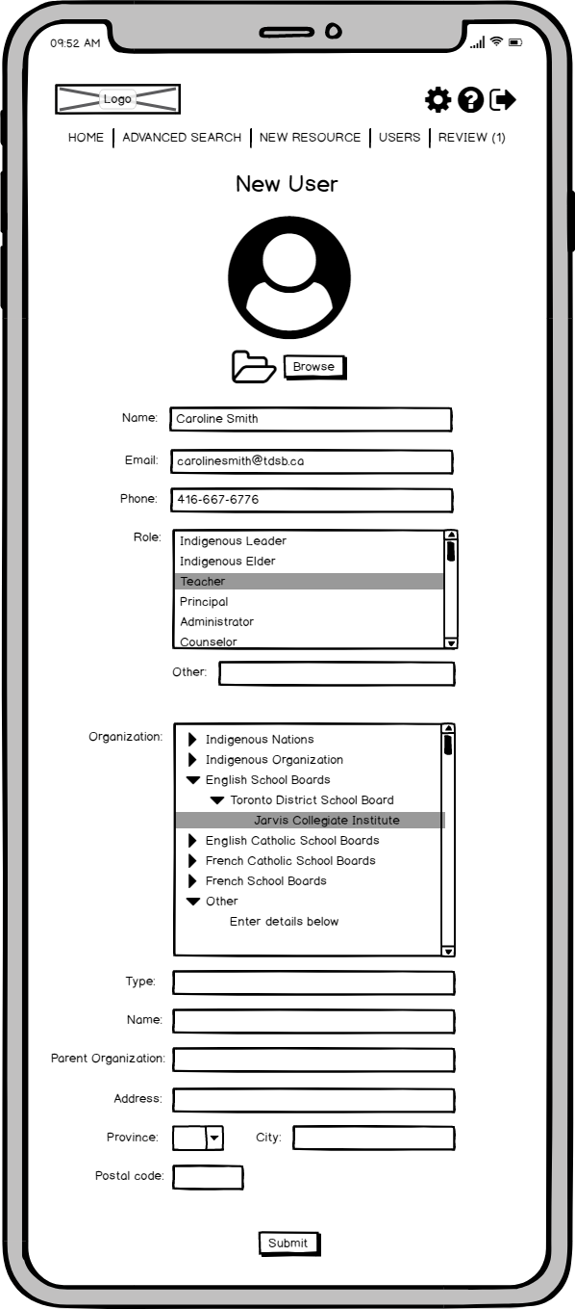
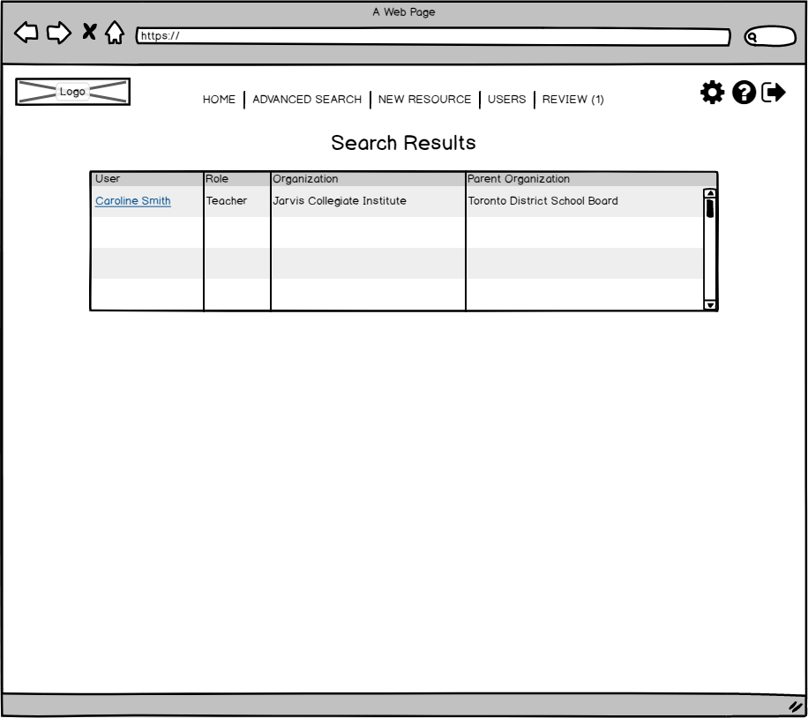

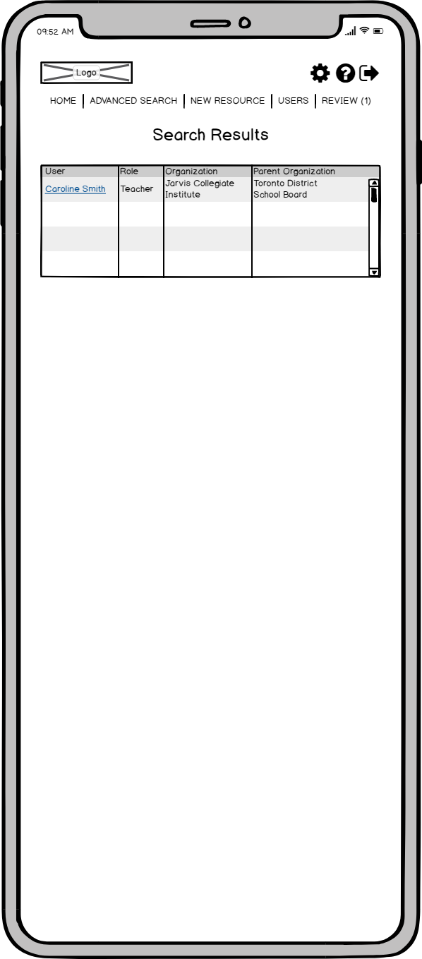
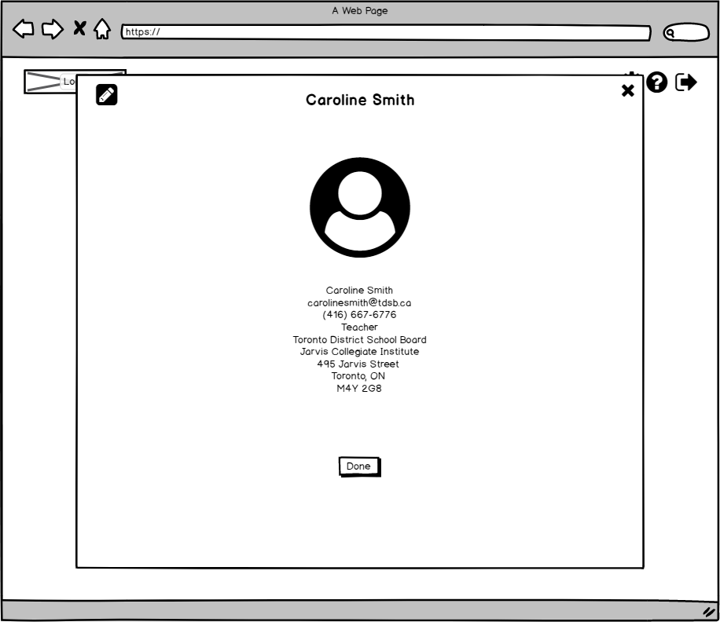
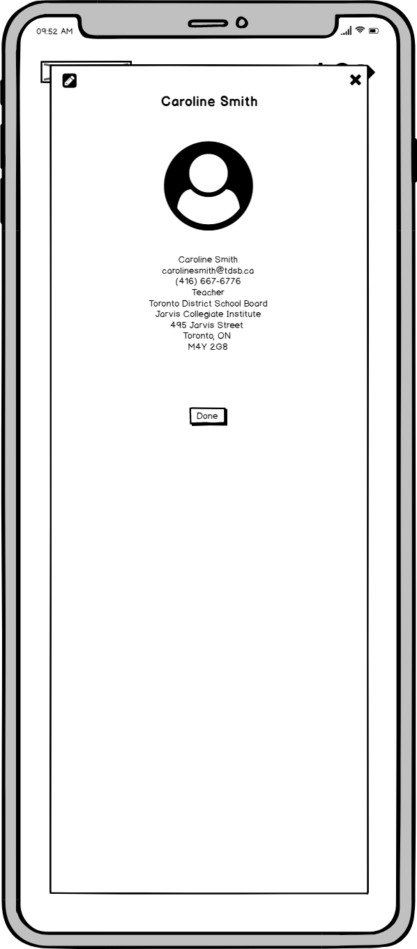

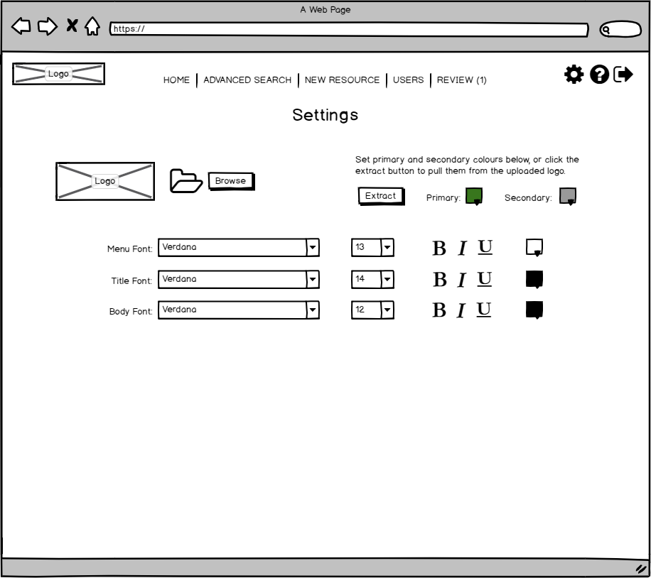

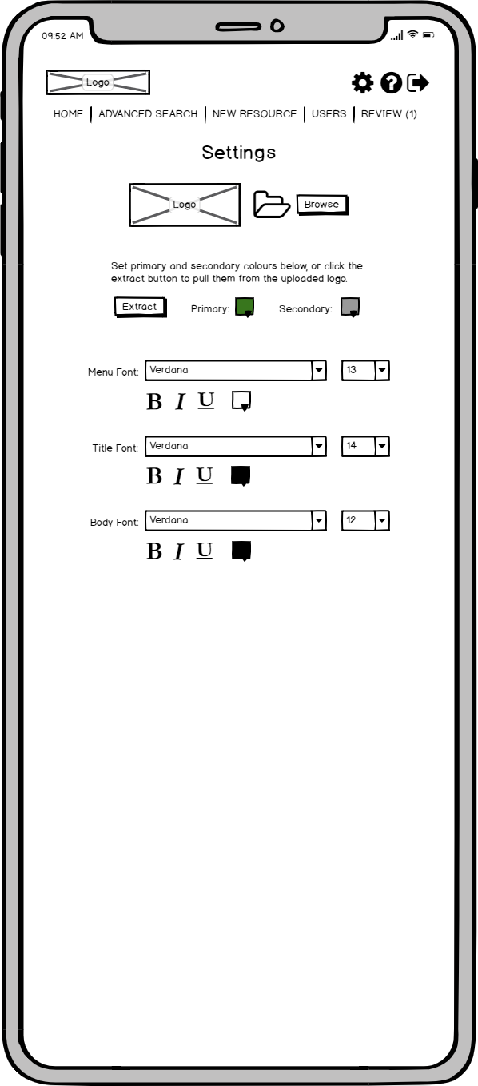

Formative Assessment Plan
The following email details the formative assessment plan.

Topic: Decolonizing and Indigenizing Ontario’s curriculum

To: <Ombudsperson>
From: Megan Clare, Instructional Designer
Date: April 14, 2020
Subject: Formative evaluation plans for the “Decolonizing & Indigenizing Resource Portal”

The purpose of this plan is to validate the “Decolonizing & Indigenizing Resource Portal” database before it is implemented throughout Ontario.

The plan consists of five reviews:
- A primary usability test
- A technical review
- An editorial review
- A secondary usability test

The purpose, procedure, timeline, and process for each of these reviews are provided in the outline below.

Review 1: Primary Usability Test

Purpose
The usability test will assess the design of the portal by collecting feedback during and after the offering of a prototype version. The prototype of the portal will be offered to a group of performers who are representative of the intended performers (Carliner, 2015).

Timing
The review will occur before development of the portal.

Participants
5 teachers from the GTA and surrounding areas (between Oshawa, Milton, and Barrie) will be invited to participate in the usability test. The teachers will be selected to ensure varied demographics (age, subject, location, gender, ethnicity) to make the group as representative as possible.

Procedure
- Schedule the usability test (reserve the location and time)
- Recruit users from the regions described above
- Provide the prototype of the portal
  - Seek feedback from the learners through the think a-loud protocol
  - Debrief their experience
  - Ask users to complete level 1 & 2 evaluation
  - Ask users to complete a follow-up evaluation
- Develop an action plan to tackle the feedback, if appropriate

Guidelines
To assess the functionality of the portal, most learners must be able to achieve the performance objectives and the user interface must be clear to them. The evaluations (level 1 & 2) must appropriately assess the learners’ reactions and engagement.

Documents to create
- Invitation to participate with instructions
- Reminder email
- Thank you email
- Action plan
A copy of these can be found in Appendix A.

Review 2: Technical Review

Purpose
The technical review focuses on the back-end and front-end design of the portal. The portal’s back-end needs to be efficiently laid out to ensure fast performance for users and ease of maintainability. The portal’s front-end needs to be intuitively laid out to simplify user experience and portal functionality.

Timing
The review will occur at the end of the first and second version.

Participants
<Name>, a consultant specializing in data analytics and software architecture, will bring significant development and quality assurance expertise.
<Name>, a consultant specializing in user experience and portal design, will bring significant usability and design expertise.

Procedure
Both of the first and second draft reviews will follow this procedure:
- Send an email to the reviewers with instructions and access to the portal
- Receive comments from the reviewers
- Determine if any comments need to be clarified and discuss them with the reviewer
- Schedule a review meeting, if needed, to clarify any unresolved comments with the reviewer(s)
- Divide comments into the following categories to prioritize changes (Carliner, 2019)
  - Showstopper – fix immediately before proceeding
  - Must do: fix before publishing
  - Nice to do: fix if time and budget permits
- Develop an action plan to tackle the comments, if appropriate

Guidelines
To assess the accuracy of the portal, the developer reviewer must ensure that the portal’s back-end is efficiently laid out to ensure fast performance for users and ease of maintainability. The UX reviewer must ensure that the portal’s front-end is intuitively laid out to simplify user experience and portal functionality.

Documents to create
- Email with instructions
- Reminder email
- Thank you email
- Invitation to a review meeting
- Action plan

A copy of these can be found in Appendix A.

Review 3: Editorial Review

Purpose
The editorial review consists of two sections (Carliner, 2019):
- Developmental review – focused on the organization and clarity of the materials
- Copyediting review – focused on proofreading and style guide compliance

Timing
The developmental review will occur at the end of the first draft.
The copyediting review will occur at the end of the final draft.

Participants
Developmental review: <Name>, a peer instructional designer at OISE who has not worked on this intervention but is familiar with others. They will bring a fresh pair of eyes and ensure functionality.
Copyediting review: <Name>, the Communications Manager for OISE, who is responsible for copyediting all interventions produced at OISE with their team.

Procedure
Developmental review:
- Send an email to the reviewers with instructions and access to the portal
- Receive comments from the reviewers
- Determine if any comments need to be clarified and discuss them with the reviewer
- Schedule a review meeting, if needed, to clarify any unresolved comments with the reviewer(s)
- Divide comments into the following categories to prioritize changes (Carliner, 2019)
  - Showstopper – fix immediately before proceeding
  - Must do: fix before publishing
  - Nice to do: fix if time and budget permits
- Develop an action plan to tackle the comments, if appropriate

Copyediting review:
- Send an email to the reviewers with instructions and access to the portal
- Receive comments from the reviewers
- Determine if any comments need to be clarified and discuss them with the reviewer
- Incorporate necessary copyedits into the final draft

Guidelines
To assess the accuracy of the drafts, the reviewers must ensure that the portal:
- Development review
  - Is intuitive and functional
- Copyediting review
  - Follow rules for grammar, spelling, and punctuation
  - Follow the style guide provided
    - Includes branding, dictionaries, citation manuals, logos, and fonts

Documents to create
Developmental review
- Email with instructions
- Reminder email
- Thank you email
- Invitation to a review meeting
- Action plan

Copyediting review
- Email with instructions
- Reminder email
- Thank you email
- Action plan

A copy of these can be found in Appendix A.

Review 4: Secondary Usability Test

Purpose
The usability test will identify areas for improvement by collecting feedback during and after the offering of a draft version. The portal will be offered to a group of performers who are representative of the intended performers (Carliner, 2015).

Timing
The review will occur after both technical reviews and before the copyediting review.

Participants
5 teachers from the GTA and surrounding areas (between Oshawa, Milton, and Barrie) will be invited to participate in the usability test. The teachers will be selected to ensure varied demographics (age, subject, location, gender, ethnicity) to make the group as representative as possible.

Procedure
- Schedule the usability test (reserve the location and time)
- Recruit users from the regions described above
- Provide the portal
  - Seek feedback from the learners through:
    - Think a-loud protocol
    - Eye tracking software
    - Hotspot software
  - Debrief their experience
  - Ask users to complete level 1 & 2 evaluation
  - Ask users to complete a follow-up evaluation
- Develop an action plan to tackle the feedback, if appropriate

Guidelines
To assess the functionality of the portal, most learners must be able to achieve the performance objectives and the user interface must be clear to them. The evaluations (level 1 & 2) must appropriately assess the learners’ reactions and engagement.

Documents to create
- Invitation to participate with instructions
- Reminder email
- Thank you email
- Action plan
A copy of these can be found in Appendix A.

Summative Evaluation Plan
The evaluation plan focuses on evaluating the effect of the portal on performance, rather than the effect of the overall campaign. Performance will be measured at three levels: 1) users’ engagement, 2) teachers’ performance, and 3) organizational performance. These levels are explained below.

Engagement
Users’ engagement with the database will be measured through four daily metrics and three annual metrics. Daily metrics will include the number of daily users, average session length, daily downloads, and rating rate. After one month, and annually afterwards, two push surveys will be launched to ask users about the usefulness of the portal and the coverage of resources.
The surveys should be designed with the following questions:
Usefulness of the Portal
- I feel the portal is useful.
  - Not at all, Not really, Somewhat, Absolutely
- I feel the portal improves my ability to decolonize and Indigenize the curriculum.
  - Not at all, Not really, Somewhat, Absolutely
- Please specify what works well and what could be improved,
  - Short answer
Coverage of Resources
- I feel I have enough resources for my curriculum.
  - Not at all, Not really, Somewhat, Absolutely
- Please specify what resources you would like.
  - Short answer

Individual Performance
Teachers’ performance will be determined through an assessment of their lesson plans and tests at an annual review meeting and through a survey of students’ beliefs and awareness of indigenous knowledge. Students’ progress will be determined by comparing their survey from the previous year and teachers will be evaluated on overall progress. The weight of each student’s performance will be dependent on their likeliness to change (i.e., their score from an assessment intervention and answer to question seven below).
The surveys should be designed with the following questions and provided online or in paper format depending on each school’s needs:
- Date
  - Pre-filled
- Full Name
  - Short answer or pre-filled
- Grade
  - Short answer or pre-filled
- I feel Indigenous beliefs should be treated with respect.
  - Not at all, Not really, Somewhat, Absolutely
- I feel Indigenous knowledge should be considered equal to Western knowledge.
  - Not at all, Not really, Somewhat, Absolutely
- I feel Indigenous issues should be taught in class.
  - Not at all, Not really, Somewhat, Absolutely
- I feel comfortable talking to my friends and family about Indigenous beliefs, knowledge, and issues.
  - Not at all, Not really, Somewhat, Absolutely
- I feel included in the curriculum.
  - Not at all, Not really, Somewhat, Absolutely
- Please provide any additional comments below.
  - Short answer

Level 4 – Organizational Performance
As the business goal is to comply with regulations, calculating the return on investment (ROI) and return on expectations (ROE) will focus on the overall goal of the initiative.
Stolovitch and Keeps (2004) define ROI as a function of value (V) and cost (C). To estimate a range, the lowest and highest estimates of values are plugged into the following equations to obtain low ROI and high ROI estimates.
ROI_{L} = [(V_{L} – C) / C] x 100 and ROI_{H} = [(V_{H} – C) / C] x 100
ROE is determined by assessing whether the results of an intervention meet the expectations set by stakeholders (Kirkpartrick & Kirkpatrick, 2010).
This intervention’s measurable goals are to save teachers activity creation time and to increase the proportion of the curriculum that is decolonized and Indigenized. Subject matter experts will be consulted to convert these measures into a monetary value to facilitate the calculation of ROI.
Creation time will be estimated for each activity and multiplied by the number of users who downloaded the activity within the first year. The total hours saved will be compared to the expected number of hours. To facilitate calculating the ROI, subject matter experts will translate this sum into a momentary representation of the hours saved or spent on other tasks.
The proportion of curriculum that has been decolonized and Indigenized will be calculated from teachers’ yearly plans and compared to the expectations set by stakeholders.
ROE and ROI may be calculated in the future using these metrics. The value for number of users downloading the activity will need to be expanded to include previously downloaded activities. Teachers’ plans will be reviewed to verify if these activities were recycled.

Appendix A

Technical Review

Email with instructions

Subject line: Technical review of the “Decolonizing & Indigenizing Resource Portal”

Dear <Name>,

The Manager of Professional Development at OISE has asked me to reach out to you about reviewing a portal I have been working on. The portal is part of performance improvement campaign and is titled “Decolonizing & Indigenizing Resource Portal”.

As a consultant with database design expertise, you are best suited to provide expert feedback on the draft portal. I am wanting to ensure that the functionality of the portal is optimized for fast performance, easy maintainability, and exceptional user experience.

Please access the portal here: <insert information>

Let me know if you have any questions.

Would you be able to send me your feedback by <deadline>?

Thank you for your time and contribution to ensuring the success of this performance campaign.

Best,
Megan

Megan Clare | Instructional Designer
<phone> | <email> | <website>

Reminder email

Subject line: Reminder – Technical review of the “Decolonizing & Indigenizing Resource Portal”

Dear <Name>,

Thank you again for participating in the technical review of the “Decolonizing & Indigenizing Resource Portal”.

I am looking forward to receiving your feedback by <deadline>. Please let me know if this deadline still works for you.

Thank you again for your time and collaboration on this program.

Best,
Megan
Megan Clare | Instructional Designer
<phone> | <email> | <website>

Thank you email

Subject line: Many thanks and review meeting – Technical review of the “Decolonizing & Indigenizing Resource Portal”

Dear <Name>,

Thank you for your feedback on the portal. I will be reviewing it and making changes where needed.

I would like to schedule a tentative review meeting with you in case I have questions about any of your feedback. I will confirm with you 3 days prior if this meeting is needed.

Please let me know which time works best for you.
- <date and time>
- <date and time>
- <date and time>

Please also provide your preferred contact method and information (i.e., Zoom ID, Skype ID, phone number, etc.).

Many thanks,
Megan
Megan Clare | Instructional Designer
<phone> | <email> | <website>

Invitation to a review meeting

Subject line: Review meeting – Technical review of the “Decolonizing & Indigenizing Resource Portal”

Dear <Name>,

Thank you again for your feedback on the portal, it has been extremely helpful. I would like to use the time we booked to review some of the comments you made so I can better apply them.

I am looking forward to speaking with you on <date> at <time>. I will <contact method> you at <contact information>.

Best,
Megan
Megan Clare | Instructional Designer
<phone> | <email> | <website>

Action plan
Comment | Priority (A/B/C) | To be addressed by | To be resolved by
<Comment> | <A, B, C> | <Name> | <Name>
<Comment> | <A, B, C> | <Name> | <Name>
<Comment> | <A, B, C> | <Name> | <Name>
<Comment> | <A, B, C> | <Name> | <Name>
…
(Carliner, 2015).

Editorial review – developmental review

Email with instructions

Subject line: Developmental review of the “Decolonizing & Indigenizing Resource Portal”

Hi <Name>,

As discussed, our manager has asked me to send you the portal I have been coordinating for a developmental review.

Please access the portal here: <insert information>

I am looking for your feedback on:
- Organization and completeness of the inputs
- Table relationships are accurate and thorough
- Selection options are correct and comprehensive
- User interface is intuitive and contains all table relationships

Would you be able to send me your feedback by <deadline>?

Thank you for your time and contribution to this intervention. Let me know if you have any questions.

I look forward to reciprocating with your section.

Best,
Megan
Megan Clare | Instructional Designer
<phone> | <email> | <website>

Reminder email

Subject line: Reminder – Developmental review of the “Decolonizing & Indigenizing Resource Portal”

Hi <Name>,

Thank you again for conducting the developmental review of the portal.

I am looking forward to receiving your feedback by <deadline>. Please let me know if this deadline still works for you.

Thank you again for your collaboration with this section.

Best,
Megan
Megan Clare | Instructional Designer
<phone> | <email> | <website>

Thank you email

Subject line: Many thanks and review meeting – Developmental review of the “Decolonizing & Indigenizing Resource Portal”

Hi <Name>,

Thank you for your feedback on the portal. I will be reviewing it and making changes where needed.

I would like to schedule a tentative review meeting with you in case I have questions about any of your feedback. I will confirm with you 3 days prior if this meeting is needed.

I have looked at our calendars and it seems like these times may work for you. Please let me know which is best suited.
- <date and time>
- <date and time>
- <date and time>

I have booked <room> for us to use.

Many thanks,
Megan
Megan Clare | Instructional Designer
<phone> | <email> | <website>

Invitation to a review meeting

Hi <Name>,

Thank you again for your feedback on my section of the program, it has been extremely helpful. I would like to use the time we booked to review some of the comments you made so I can better apply them.

I am looking forward to speaking with you on <date> at <time> in the <room>.

Best,
Megan
Megan Clare | Instructional Designer
<phone> | <email> | <website>

Action plan
Comment | Priority (A/B/C) | To be addressed by | To be resolved by
<Comment> | <A, B, C> | <Name> | <Name>
<Comment> | <A, B, C> | <Name> | <Name>
<Comment> | <A, B, C> | <Name> | <Name>
<Comment> | <A, B, C> | <Name> | <Name>
…
(Carliner, 2015).

Editorial review – copyediting review

Email with instructions

Subject line: Editorial review of the “Decolonizing & Indigenizing Resource Portal”

Good <morning/afternoon> <Name>,

As discussed, my manager has asked me to send you the portal I have been coordinating for an editorial review.

Please access the portal here: <insert information>

I have attached the terminology list and style guide provided by the Ministry of Ontario. In addition to your typical copyediting, please ensure all the names of communities and terms are consistent and used appropriately.

Would you be able to send me your feedback by <deadline>?

Thank you for your time and contribution to this section of the program. Let me know if you have any questions.

Best,
Megan
Megan Clare | Instructional Designer
<phone> | <email> | <website>

Reminder email

Subject line: Reminder – Editorial review of the “Decolonizing & Indigenizing Resource Portal”

Good <morning/afternoon> <Name>,

Thank you again for conducting the editorial review of the portal.

I am looking forward to receiving your feedback by <deadline>. Please let me know if this deadline still works for you.

Thank you again for your collaboration with this section.

Best,
Megan
Megan Clare | Instructional Designer
<phone> | <email> | <website>

Thank you email

Subject line: Many thanks and review meeting – Developmental review of the “Decolonizing & Indigenizing Resource Portal”

Good <morning/afternoon> <Name>,

Thank you for your feedback on the portal. I will be reviewing it and making changes where needed.

I would like to schedule a tentative review meeting with you in case I have questions about any of your feedback. I will confirm with you 3 days prior if this meeting is needed.

I have looked at our calendars and it seems like these times may work for you. Please let me know which is best suited.
- <date and time>
- <date and time>
- <date and time>

I have booked <room> for us to use.

Many thanks,
Megan
Megan Clare | Instructional Designer
<phone> | <email> | <website>

Invitation to a review meeting

Good <morning/afternoon> <Name>,

Thank you again for your feedback on the portal, it has been extremely helpful. I would like to use the time we booked to review some of the comments you made so I can better apply them.

I am looking forward to speaking with you on <date> at <time> in the <room>.

Best,
Megan
Megan Clare | Instructional Designer
<phone> | <email> | <website>

Usability test

Invitation to participate with instructions

Subject line: Request for participation and feedback on new resource portal

Dear <Name>,

We would like to invite you to help user test a new resource portal for decolonizing and Indigenizing the curriculum. Your <characteristic – length of career, subject, city/rural, reputation for excellence, modern approach, etc.> will help us assess the training from a <related characteristic> perspective.

The user test will be held from <start time> to <end time> on <date> at OISE (please see the attached directions). We will use your feedback from this user test to improve the portal before we launch it within the province.

We will serve coffee, tea, and snacks during the user test. There are many places nearby to purchase lunch, and there will be a kitchenette available if you prefer to bring your lunch.

Please let me know by <date> if you are available to participate. Please also let me know if you have any questions.

Best,
Megan
Megan Clare | Instructional Designer
<phone> | <email> | <website>

Reminder email

Subject line: Reminder: user test of new resource portal on <date> from <start time> to <end time>

Dear <Name>,

Thank you for taking the time to help us user test the new resource portal for decolonizing and Indigenizing the curriculum.

We look forward to meeting you on <date>. Please ensure to arrive at OISE by < 15 minutes before start time> as we will be starting promptly at <start time>. We will wrap up the session by <end time>. Please see the attached directions and details for finding <room, building>.

As a reminder, we will serve coffee, tea, and snacks during the user test. There are many places nearby to purchase lunch, and there will be a kitchenette available if you prefer to bring your lunch.

Thank you again for agreeing to participate in our user test. Please reach out if you have any questions in the meantime.

Best,
Megan
Megan Clare | Instructional Designer
<phone> | <email> | <website>

Thank you email

Subject line: Many thanks for helping us user test the new resource portal!

Dear <Name>,

Thank you again for taking the time to help us user test the new resource portal. Your feedback was extremely useful to our team.

Please let me know if you would be interested in participating in our future user tests. We hope you stay connected and look forward to seeing you at future events.

Best,
Megan
Megan Clare | Instructional Designer
<phone> | <email> | <website>

Action plan
Comment | Priority (A/B/C) | To be addressed by | To be resolved by
<Comment> | <A, B, C> | <Name> | <Name>
<Comment> | <A, B, C> | <Name> | <Name>
<Comment> | <A, B, C> | <Name> | <Name>
<Comment> | <A, B, C> | <Name> | <Name>
…
(Carliner, 2015).

References
Carliner, S. (2015). Training design basics (2nd ed). Alexandria, VA: ATD Press.
Garrett, J. (2011). The elements of user experience (2nd ed). Berkeley, CA: New Riders.
Kirkpatrick, J. D., & Kirkpatrick, W. K. (2010). ROE’s rising star: Why return on expectations is getting so much attention. T&D.
Stolovitch, H. D. & Keeps, E. J. (2004). Training ain’t performance. ASTD Press.

